**Cloud computing azure project**

**Project name : Alternative Entertainment Application.**

**Group member : Masud sayyed , Vikram shinde**

**Kaif khache**

**Institution : Magicbus**

**Azure service used : Application Gateway ,**

**Traffic manager , Virtual network , Virtual machine ,**

Azure Portal.

The Azure portal is a web-based, unified console that provides an alternative to command-line tools. You can manage your Azure subscription with the Azure portal. Build, manage, and monitor everything from simple web apps to complex cloud deployments.

Virtual Machine.

A VM is a virtualized instance of a computer that can perform almost all of the same functions as a computer, including running applications and operating systems. Virtual machines run on a physical machine and access computing resources from software called a hypervisor.

Subnet

A subnet, or subnetwork, is a segmented piece of a larger network. More specifically, subnets are a logical partition of an IP network into multiple, smaller network segments. The Internet Protocol (IP) is the method for sending data from one computer to another over the internet.

Application Gateway

An app gateway is an enterprise security solution that lets users access traditional web applications hosted in corporate data centers using the same logon credentials and methods they use to access mobile apps and cloud services.

Availability Set.

An availability set is a logical grouping of VMs that allows Azure to understand how your application is built to provide for redundancy and availability.

WAF Policy.

Web Application Firewall Policies contain all the WAF settings and configurations. This includes exclusions, custom rules, managed rules, and so on. These policies are then associated to an application gateway (global), a listener (per-site), or a path-based rule (per-URI) for them to take effect

Frontends

Azure Front Door is a modern cloud content delivery network (CDN) service that delivers high performance, scalability, and secure user experiences for your content and applications

IIS server

Internet Information Services (IIS) is a flexible, general-purpose web server from Microsoft that runs on Windows systems to serve requested HTML pages or files. An IIS web server accepts requests from remote client computers and returns the appropriate response.

DNS

The Domain Name System (DNS) Server is a server that is specifically used for matching website hostnames (like example.com)to their corresponding Internet Protocol or IP addresses.

Traffic Manager

Azure Traffic Manager operates at the DNS layer to quickly and efficiently direct incoming DNS requests based on the routing method of your choice.

**Alternative Entertainment Application.**

Start Azure Portal.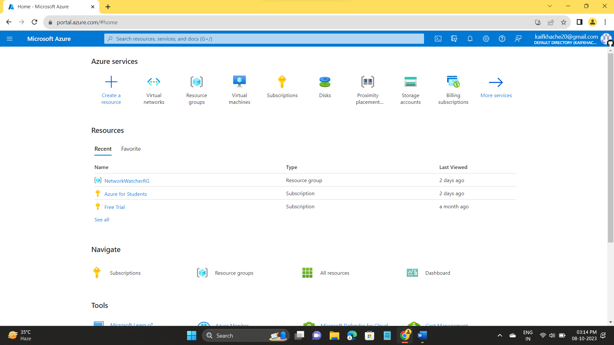

Create a Virtual Machine.

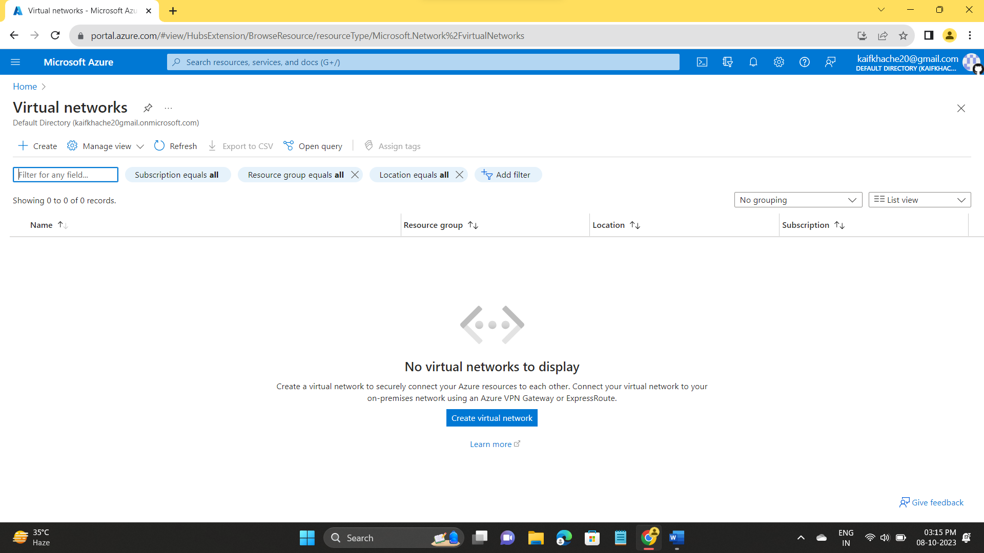

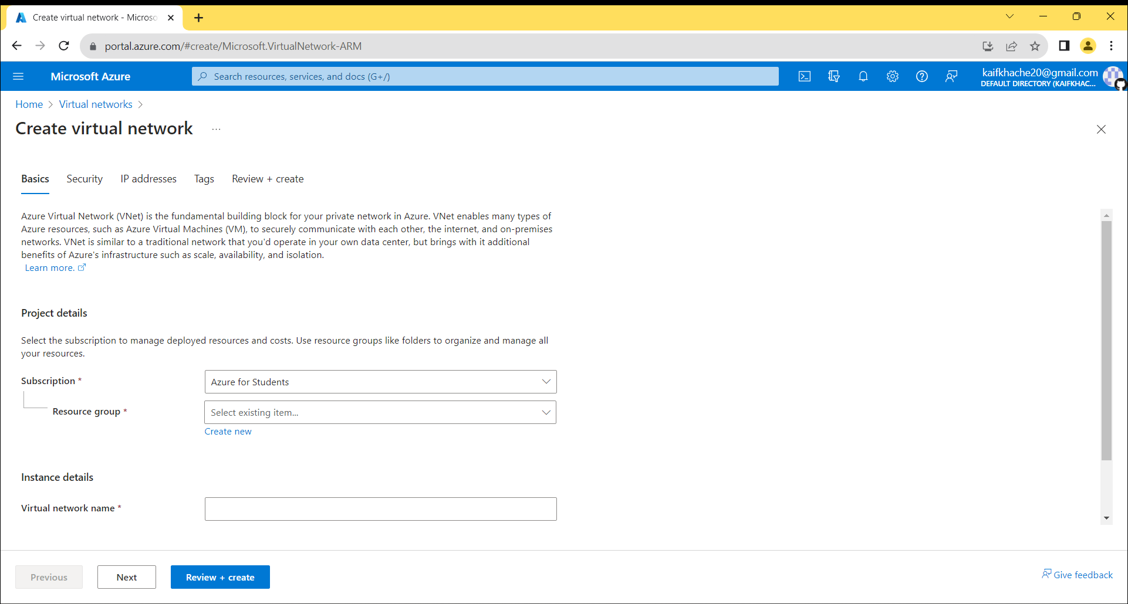

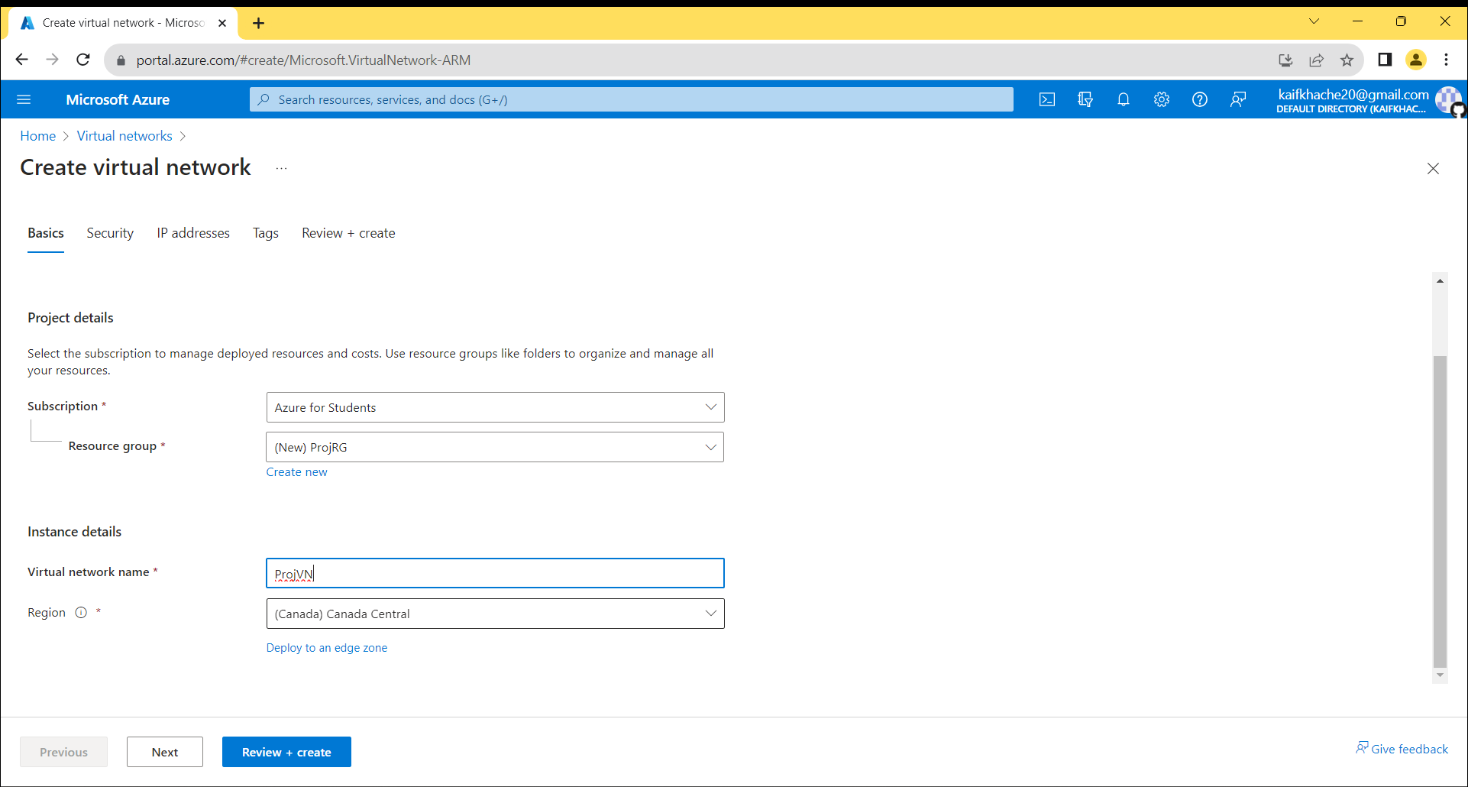

Create 3 different Subnet for 2 virtual Machine and 1 Application Gateway

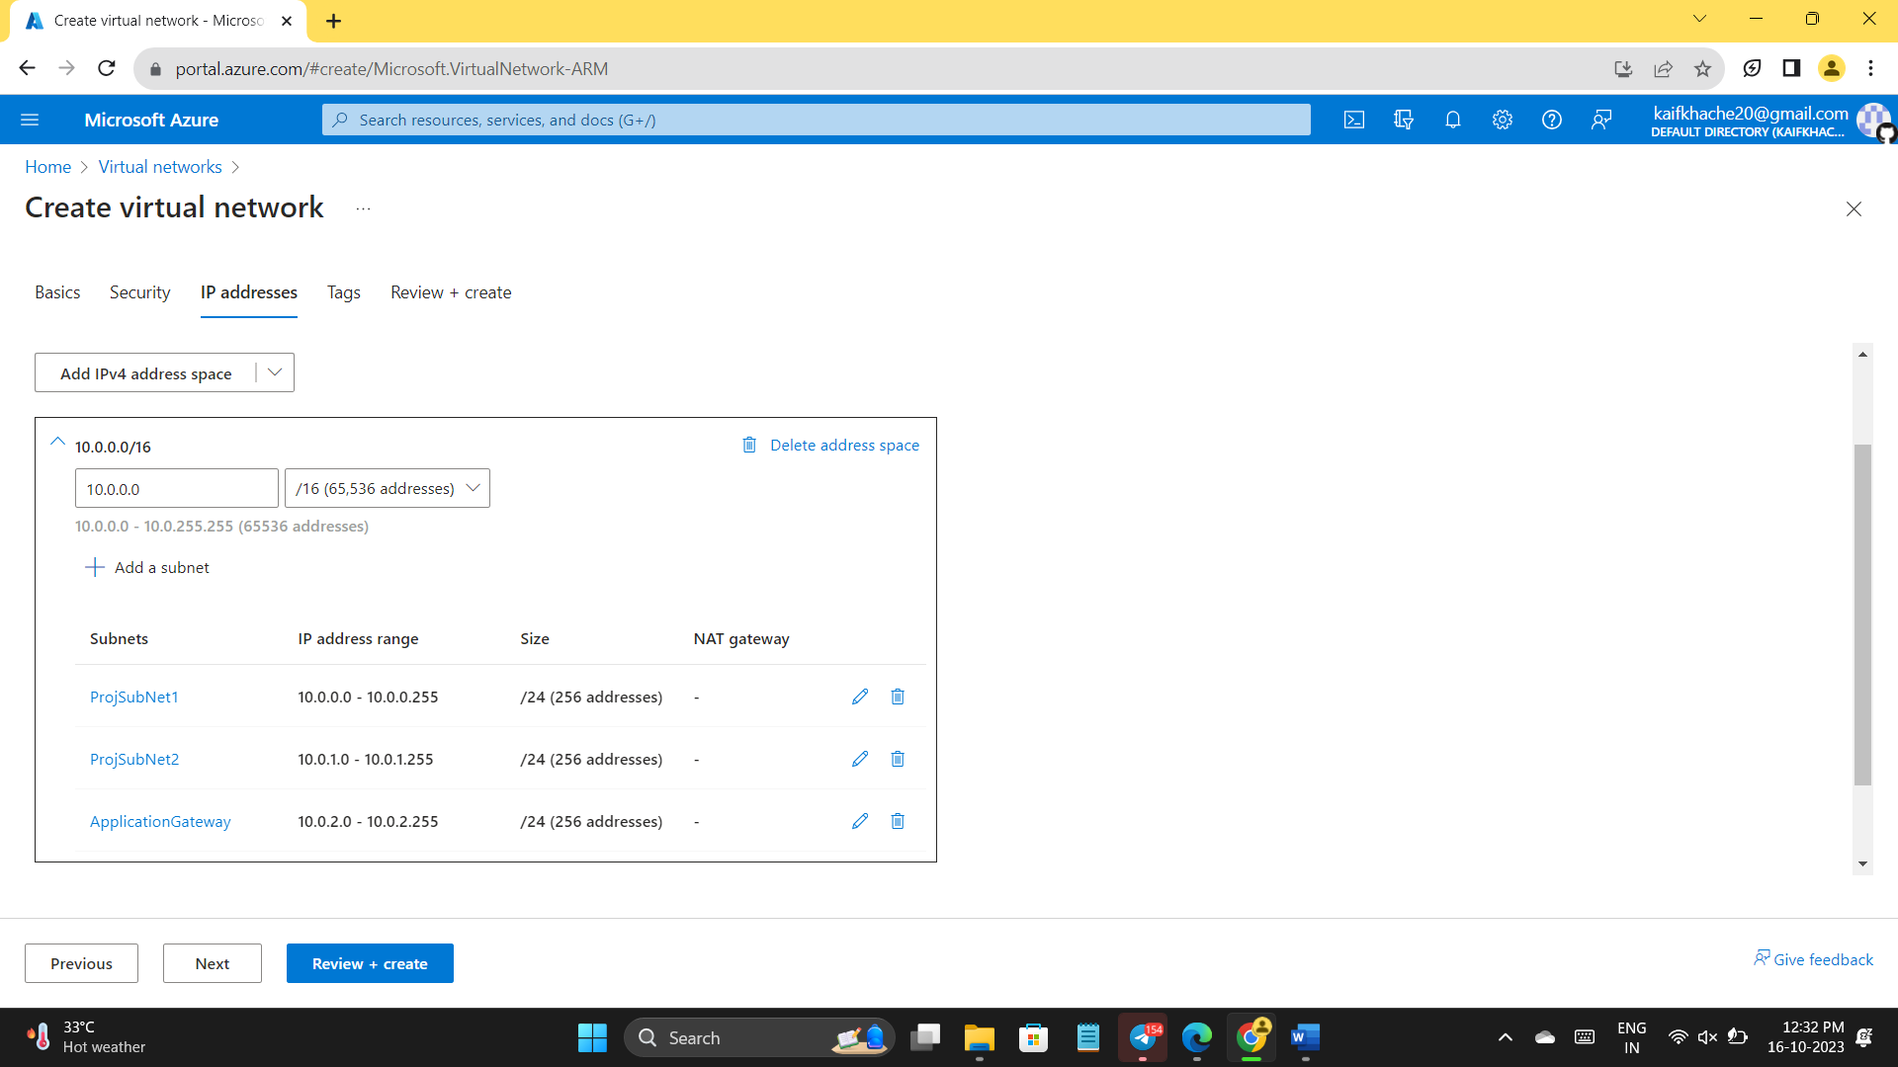

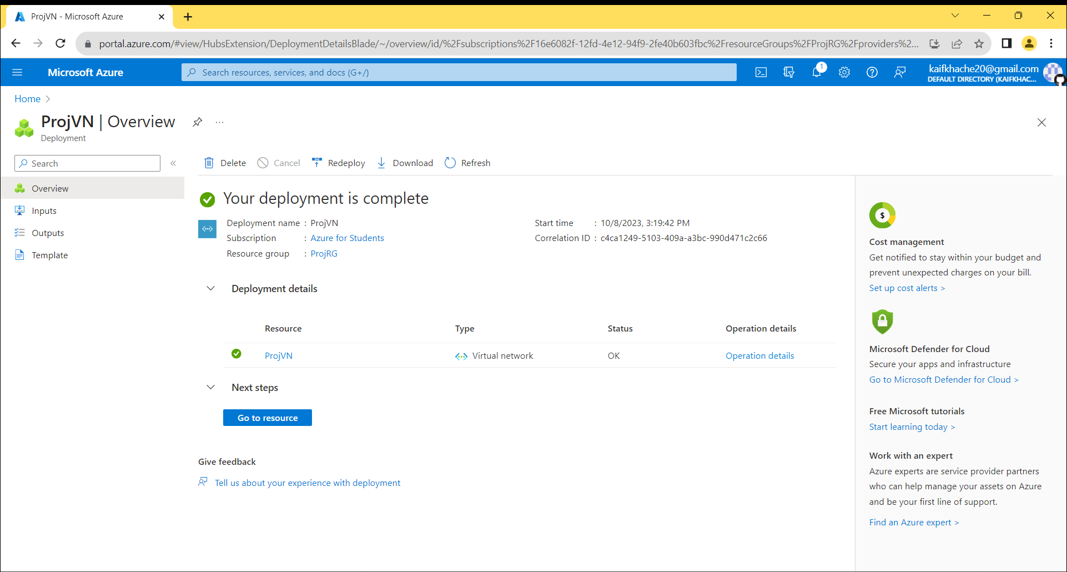

Create 2 Different Virtual Machine Both in same Availability Set.

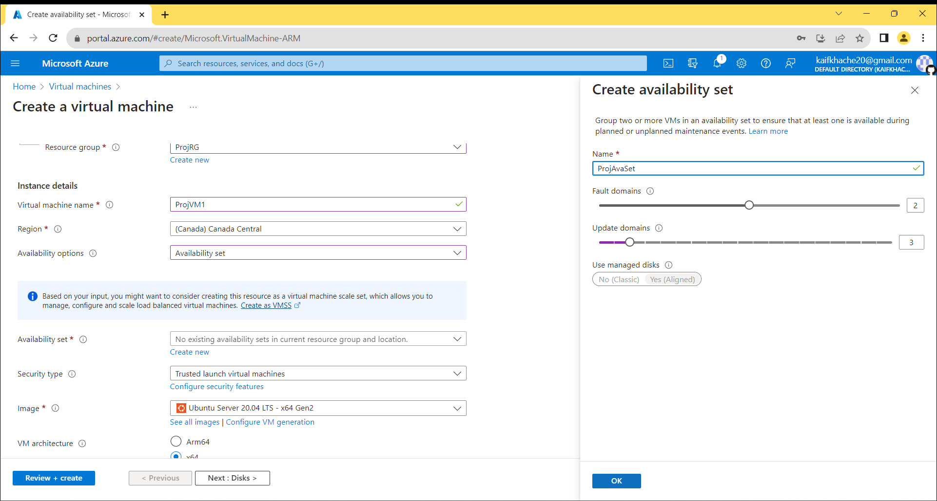

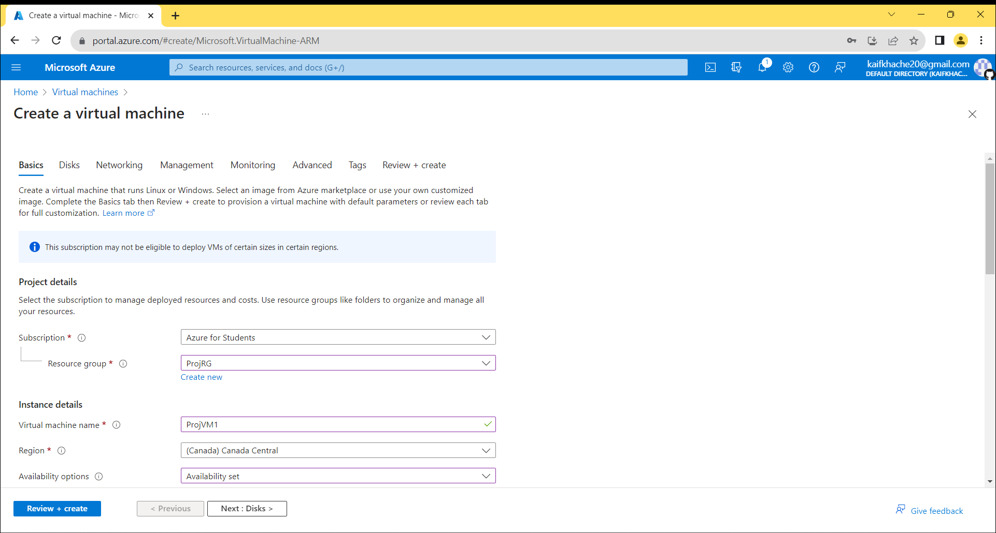

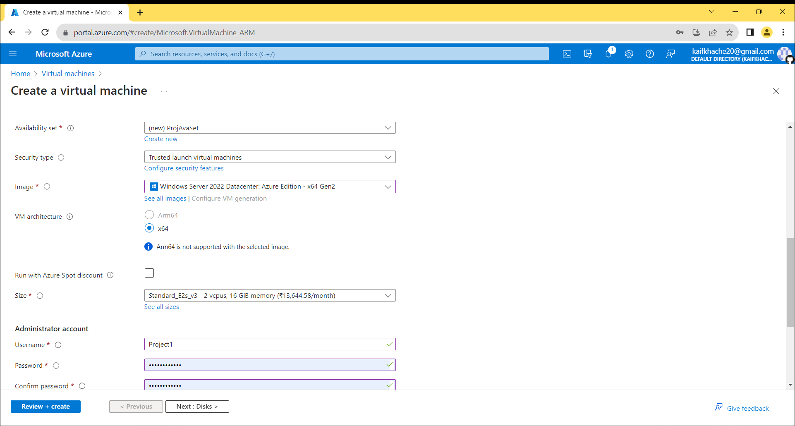

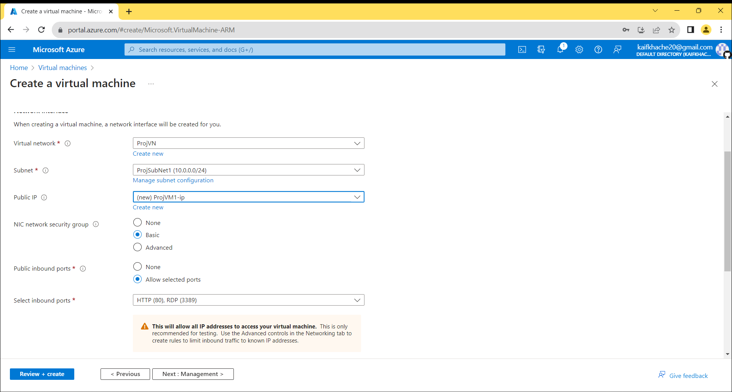

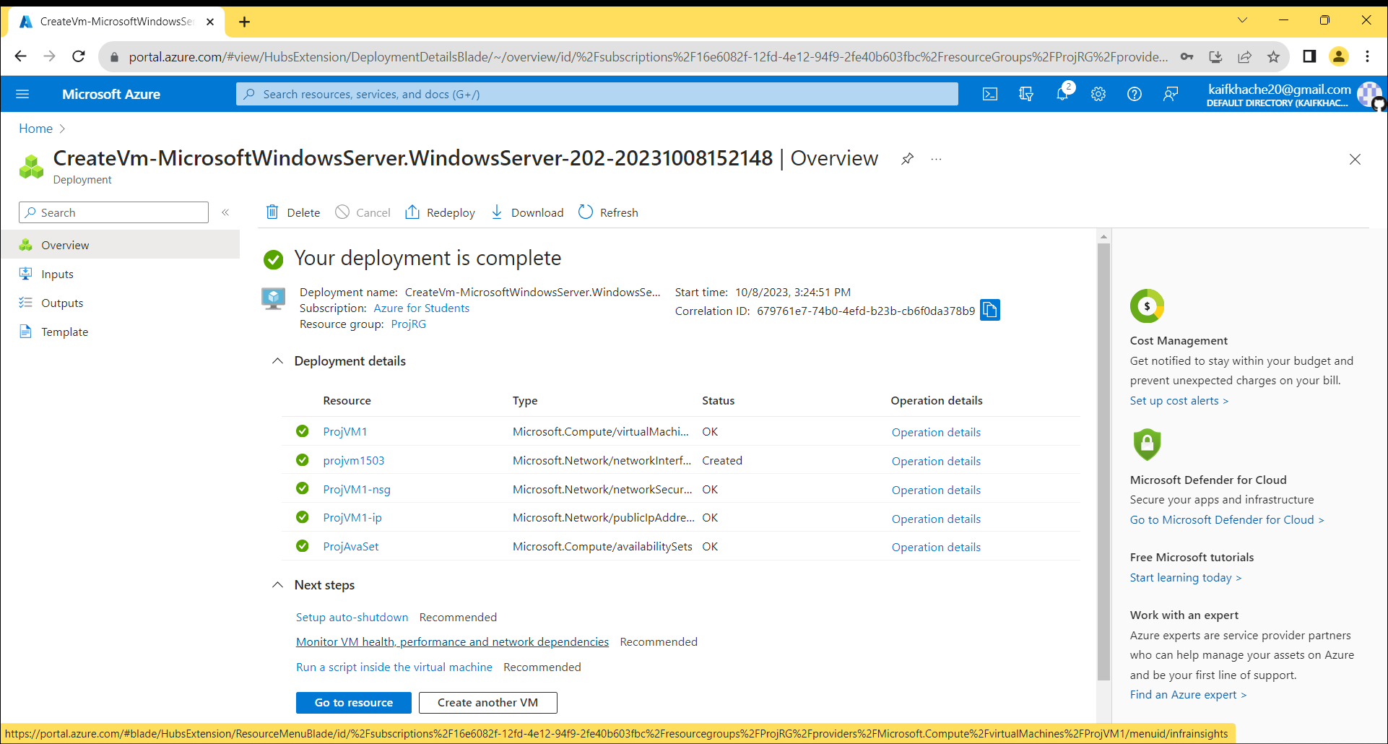

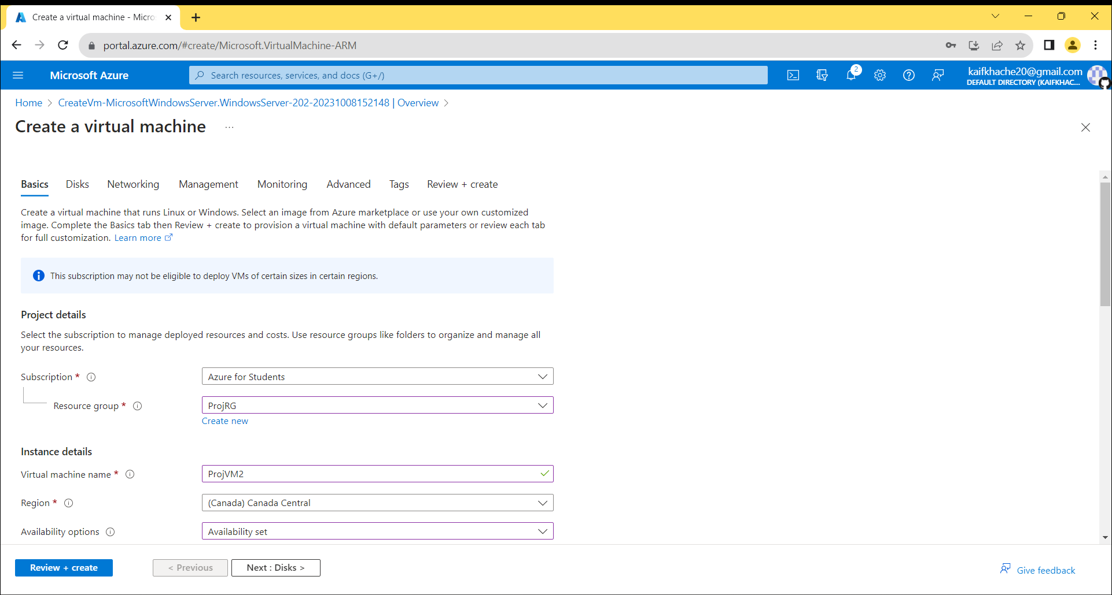

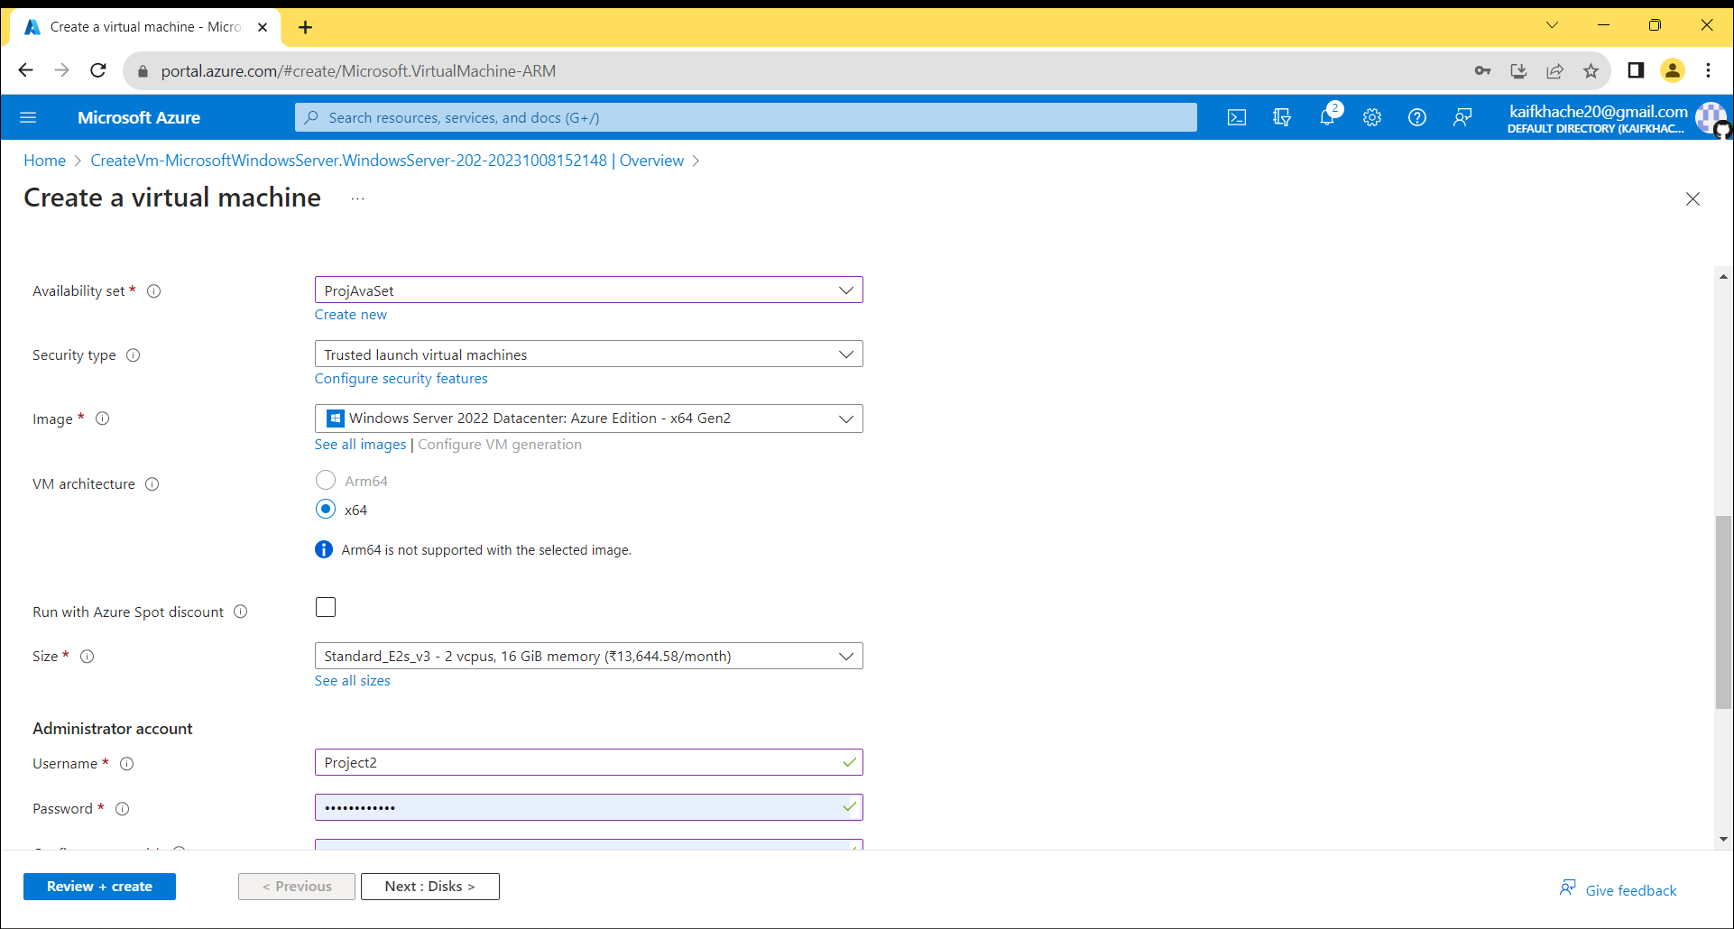

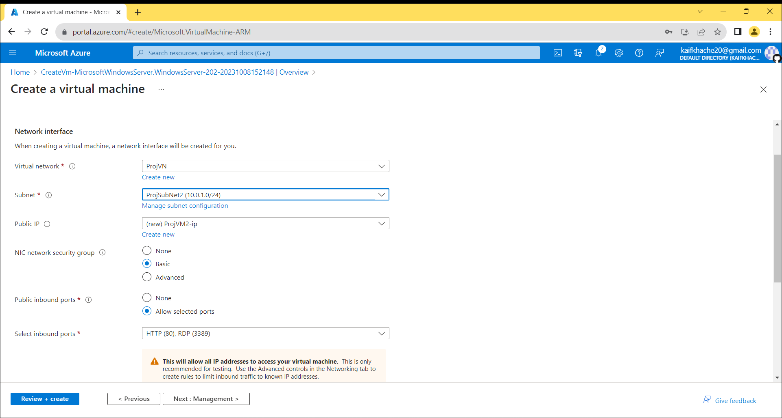

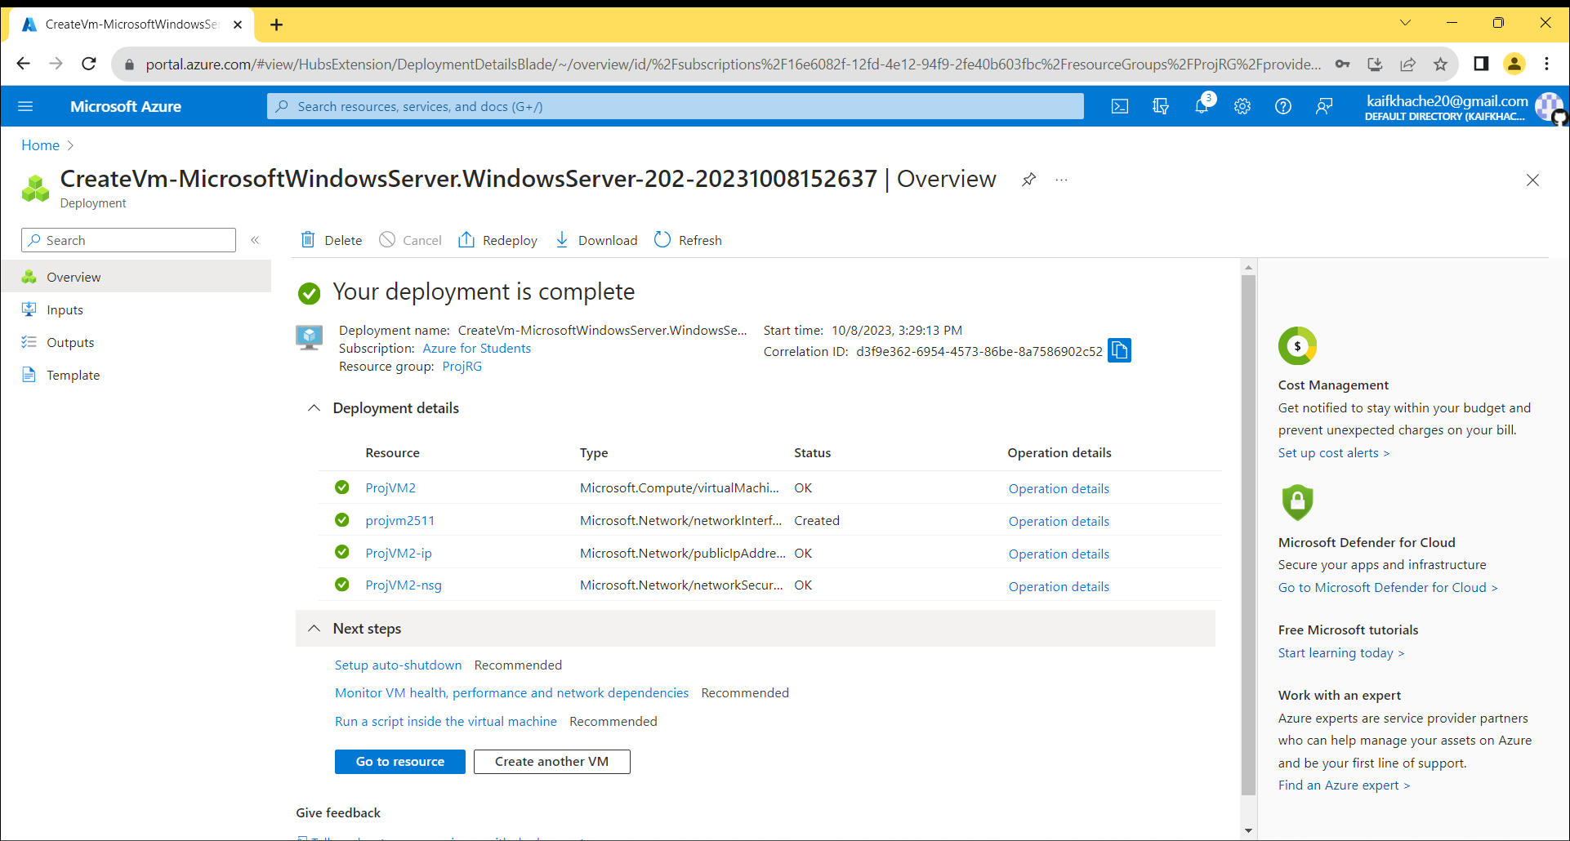

Create A New Application Gateway.

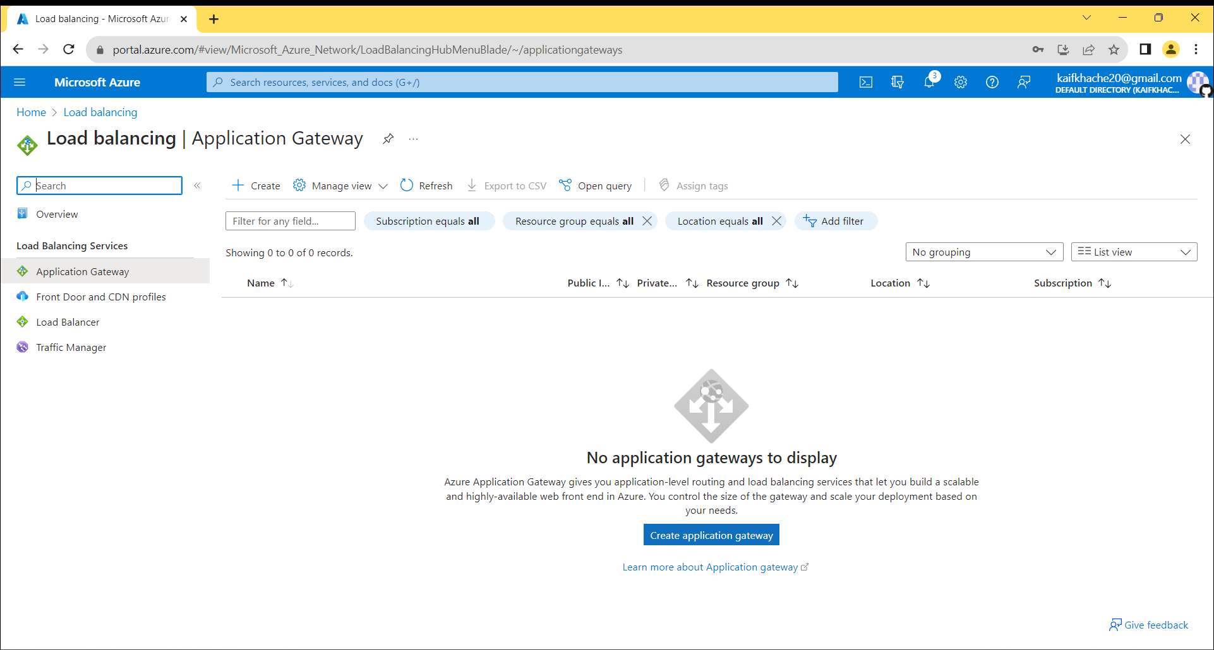

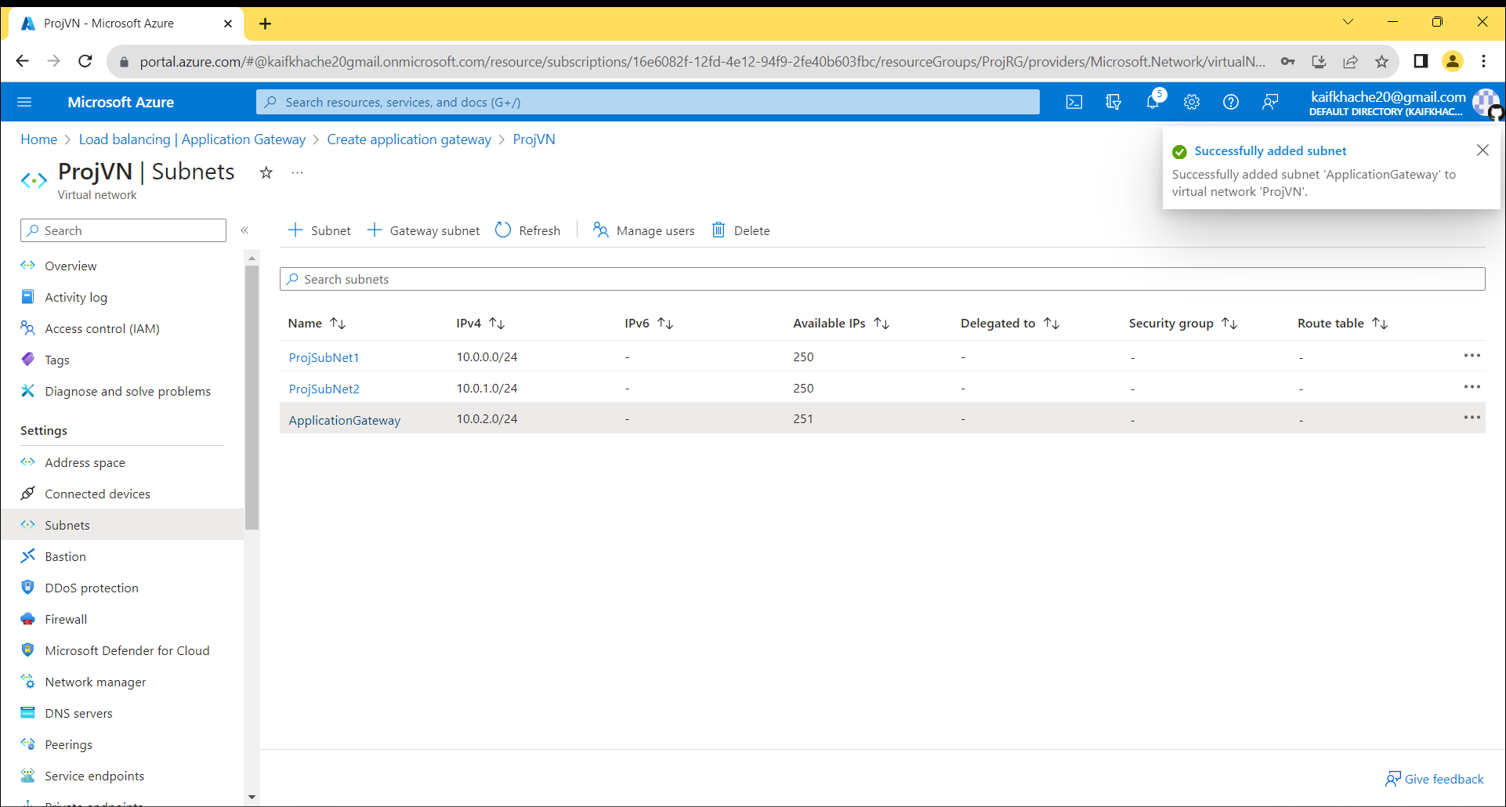

Create WAF Policy.

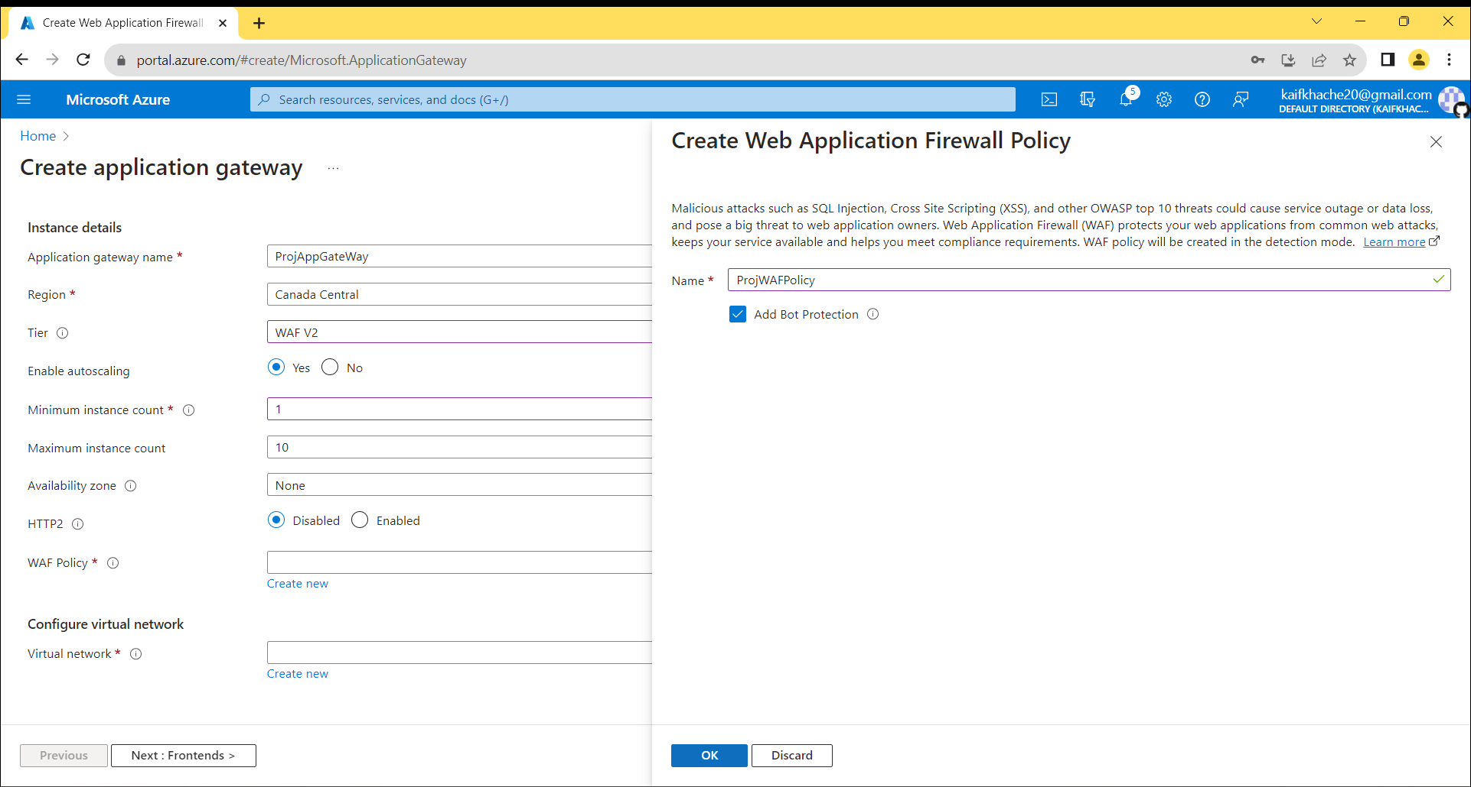

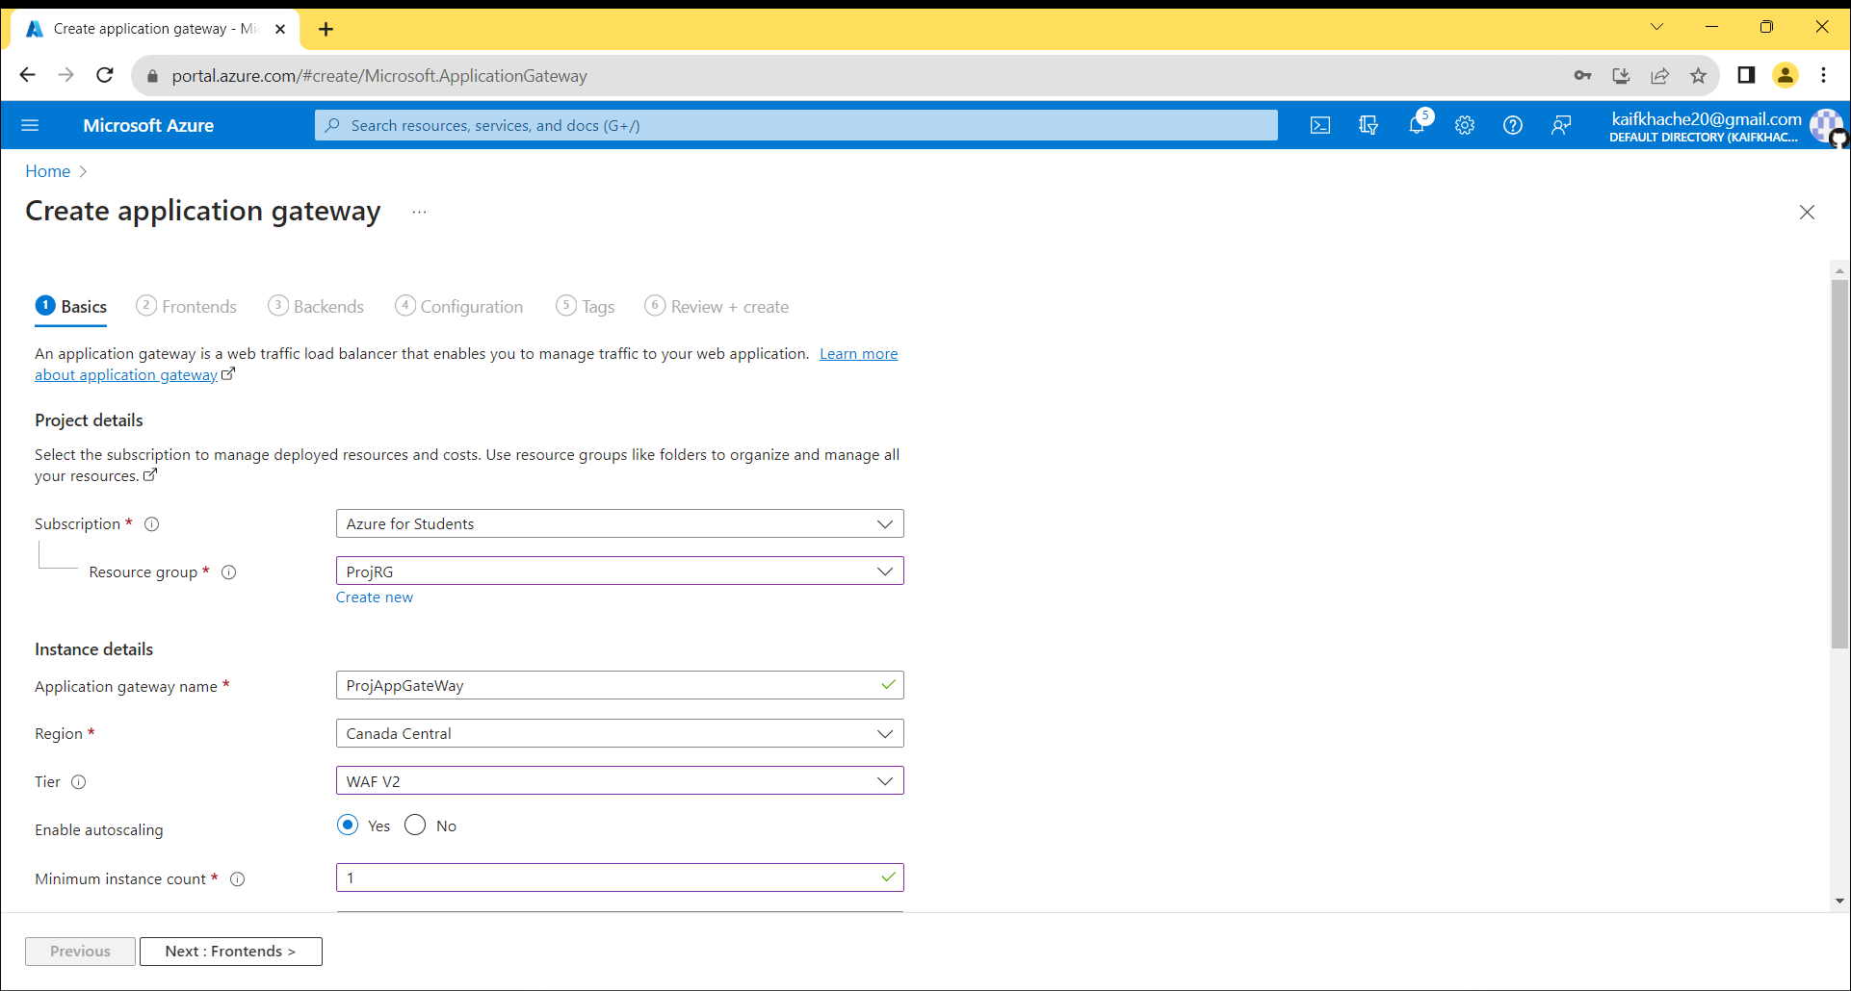

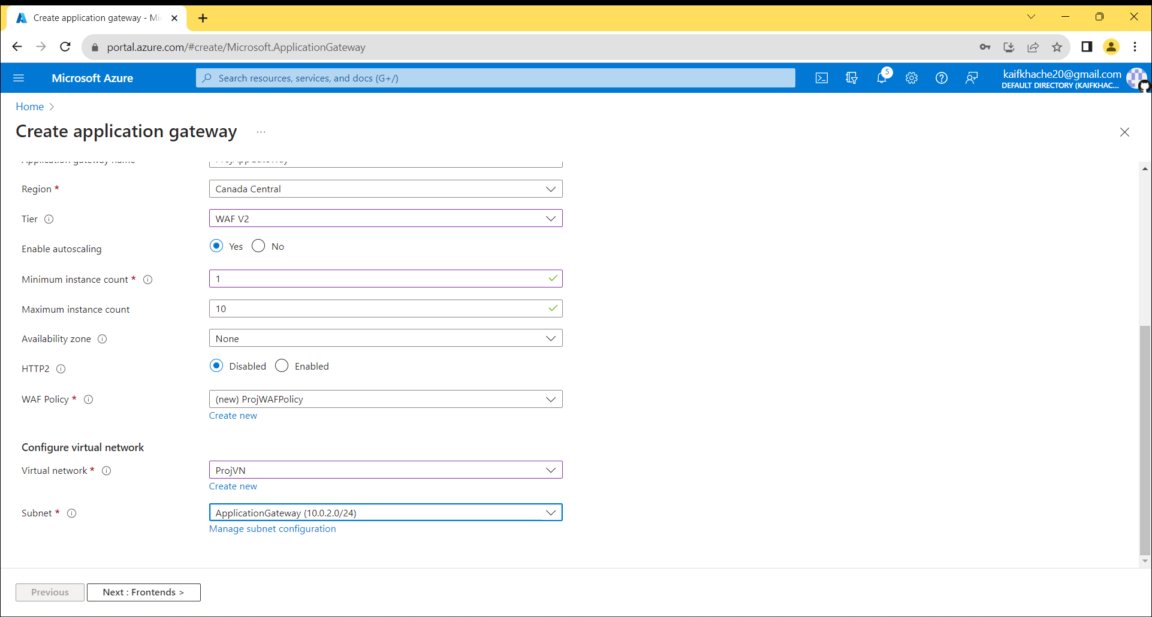

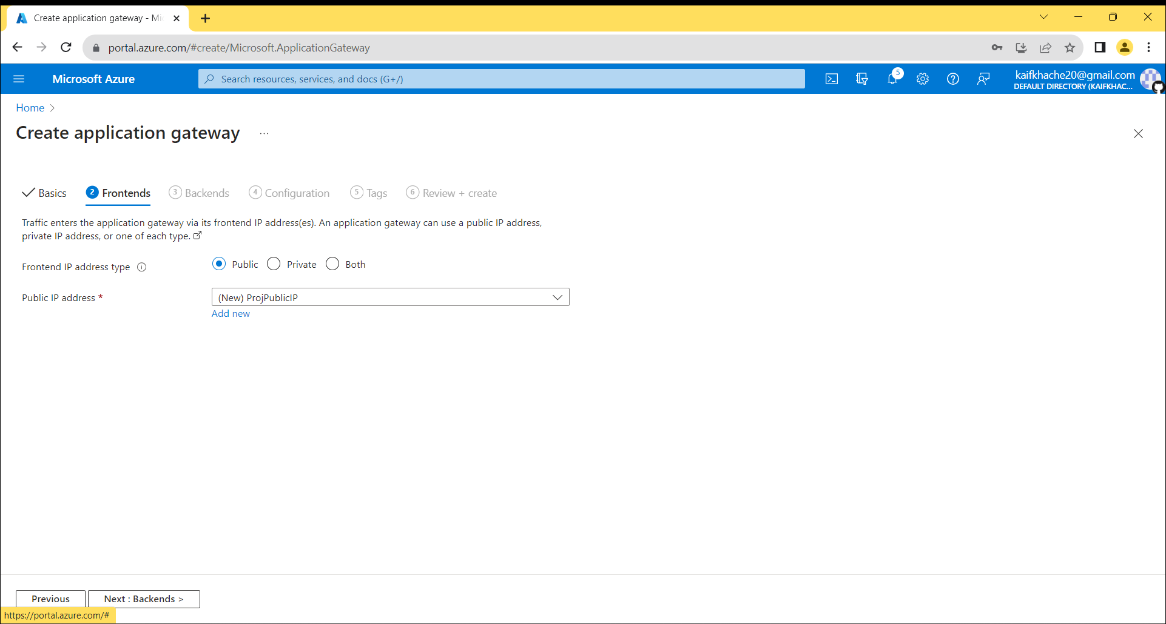

Create 2 Different Backend Pool for Different Virtual Machine

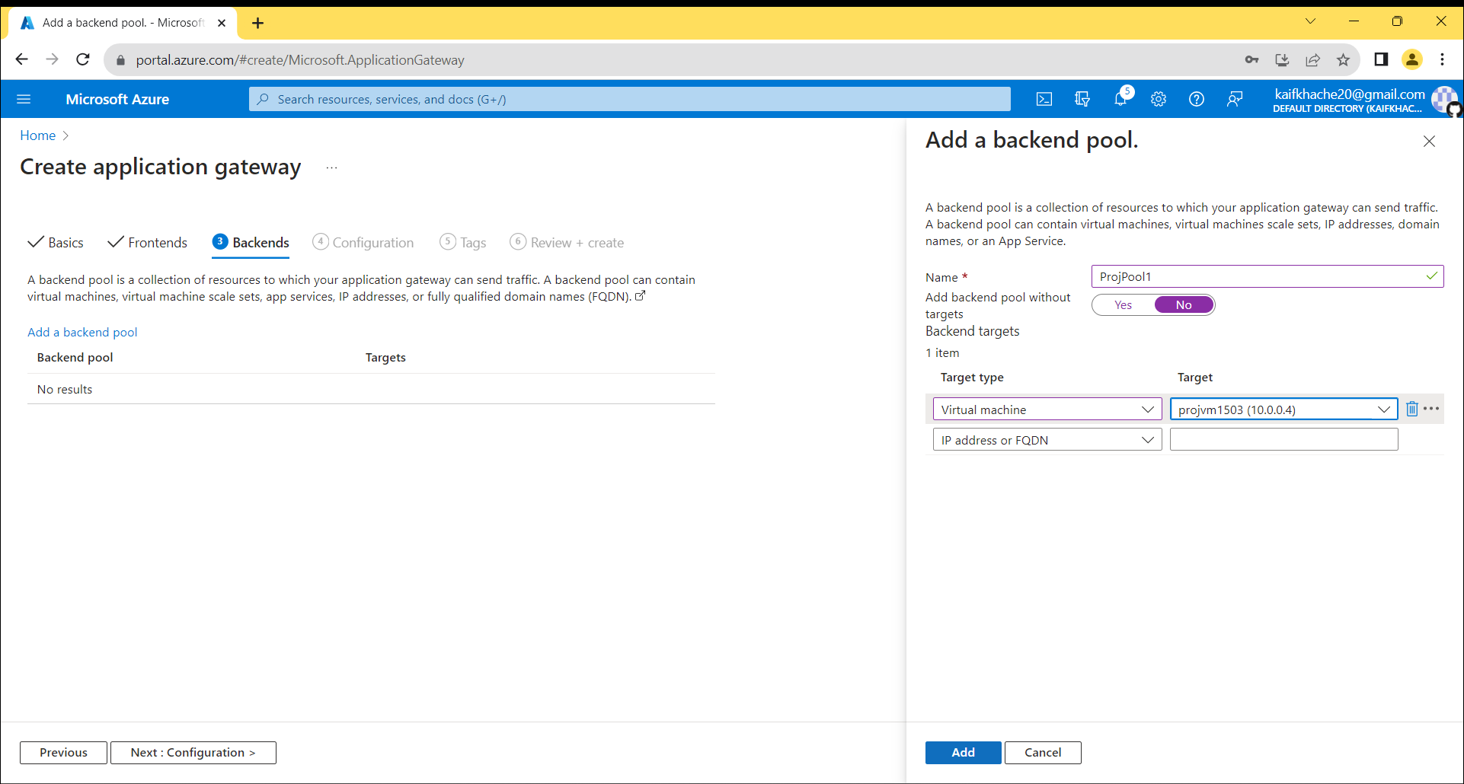

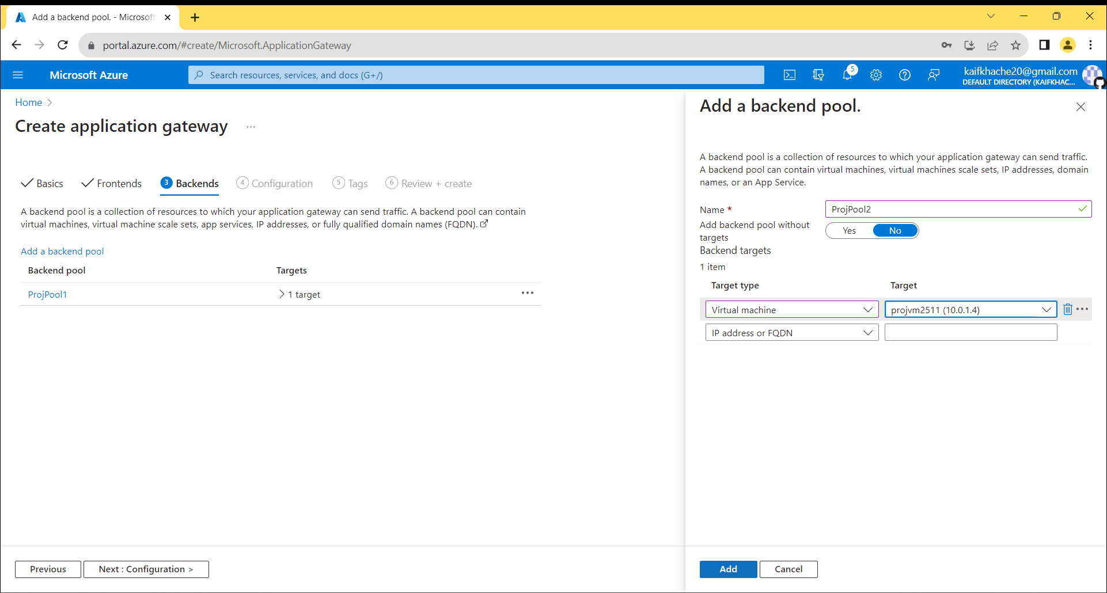

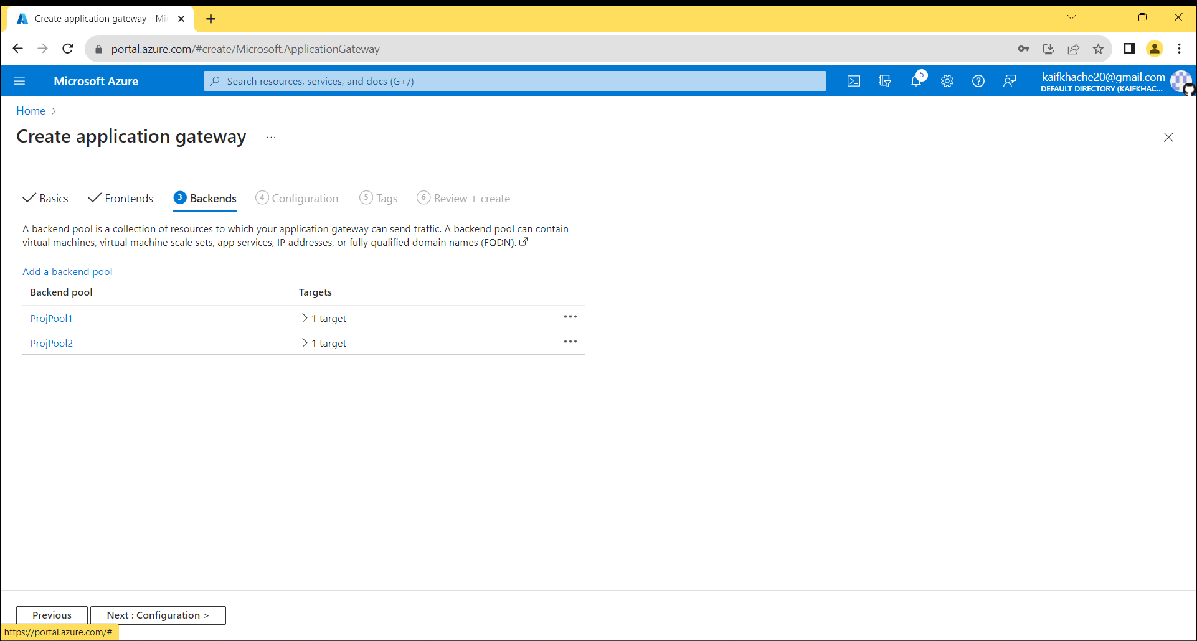

Create 2 Different Frontends

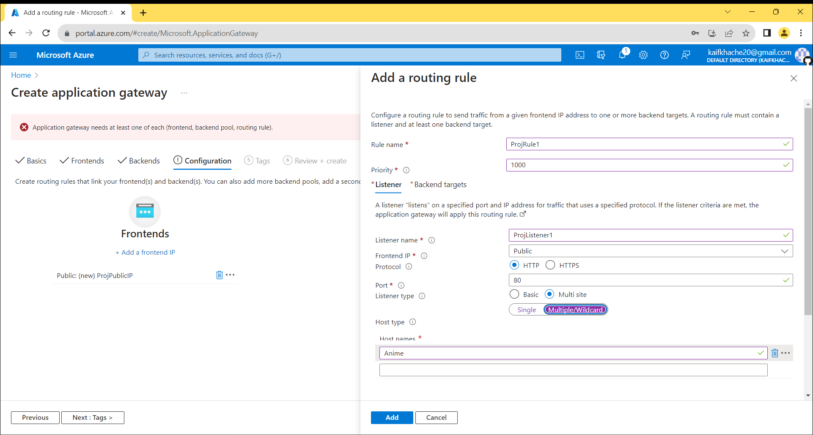

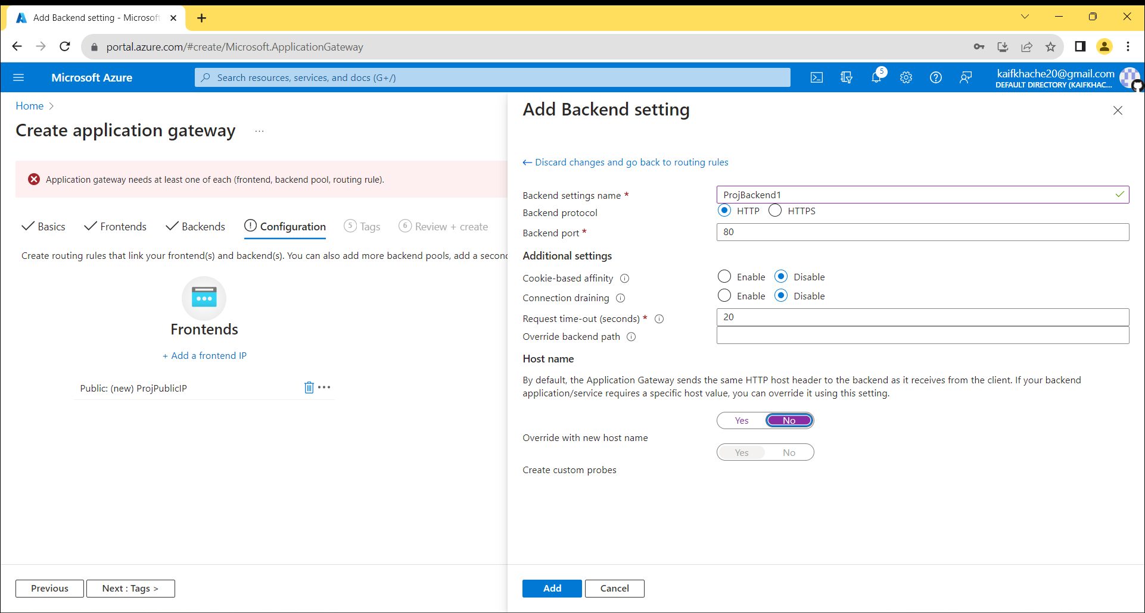

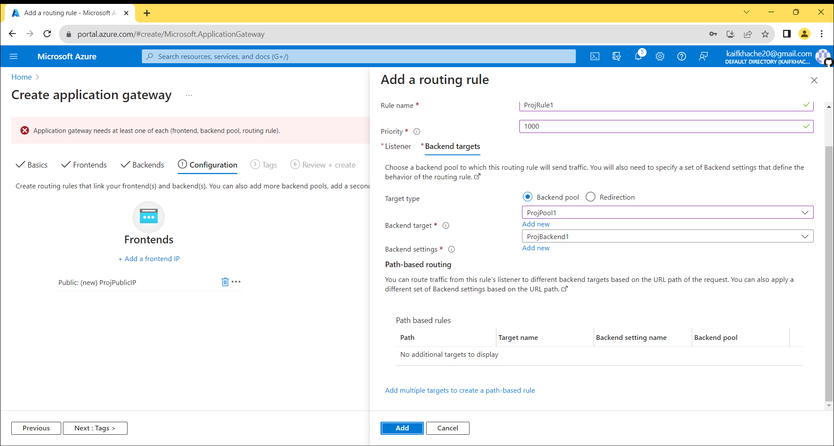

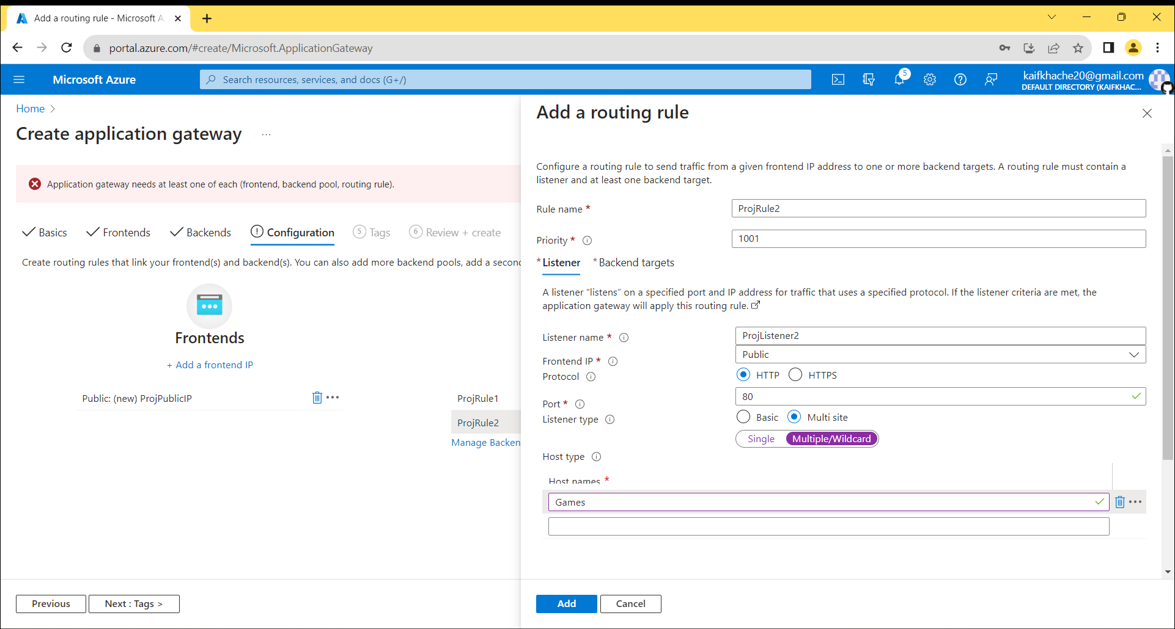

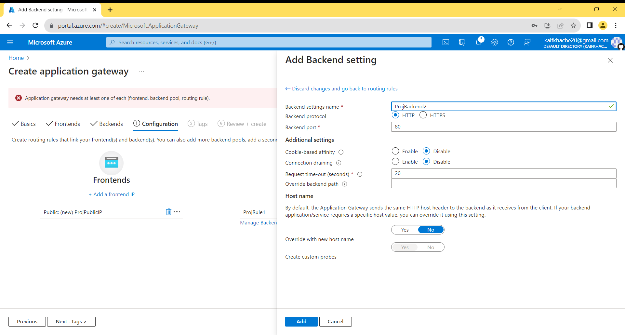

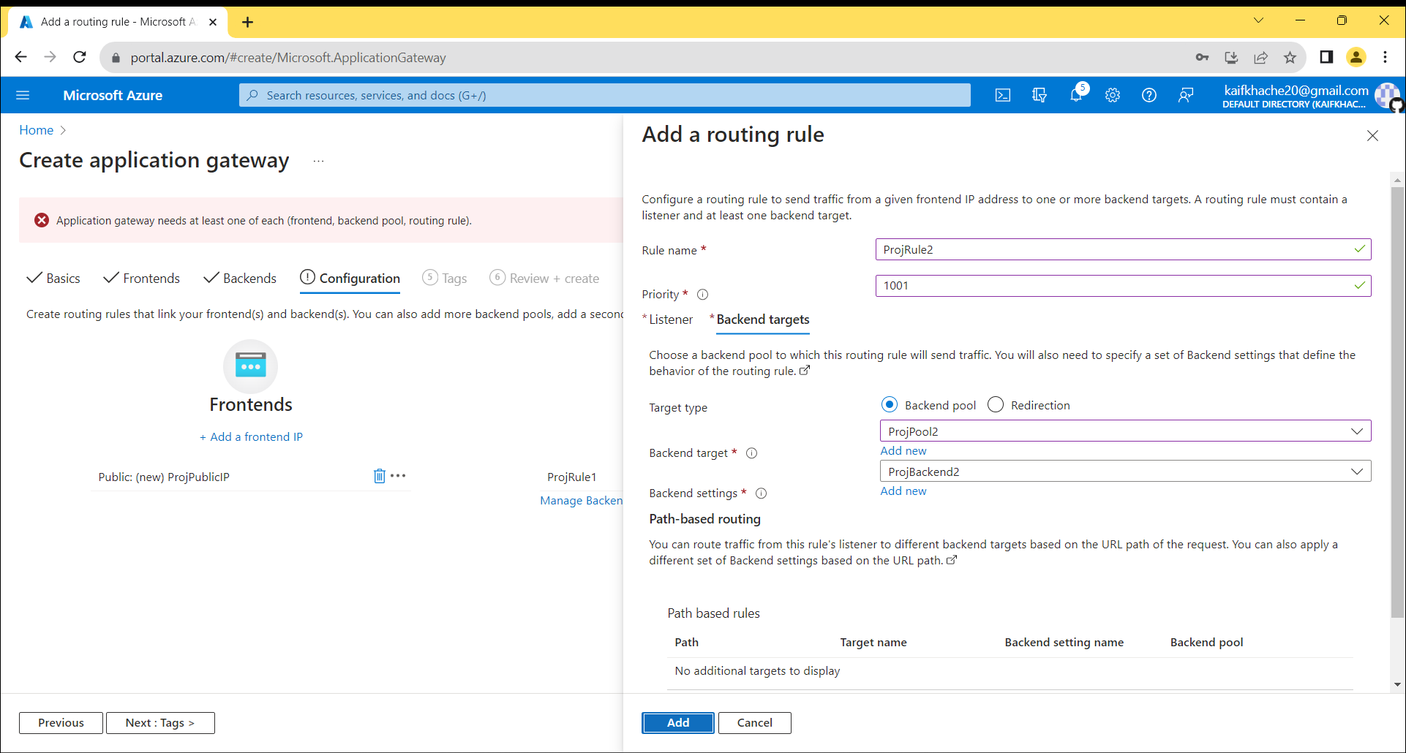

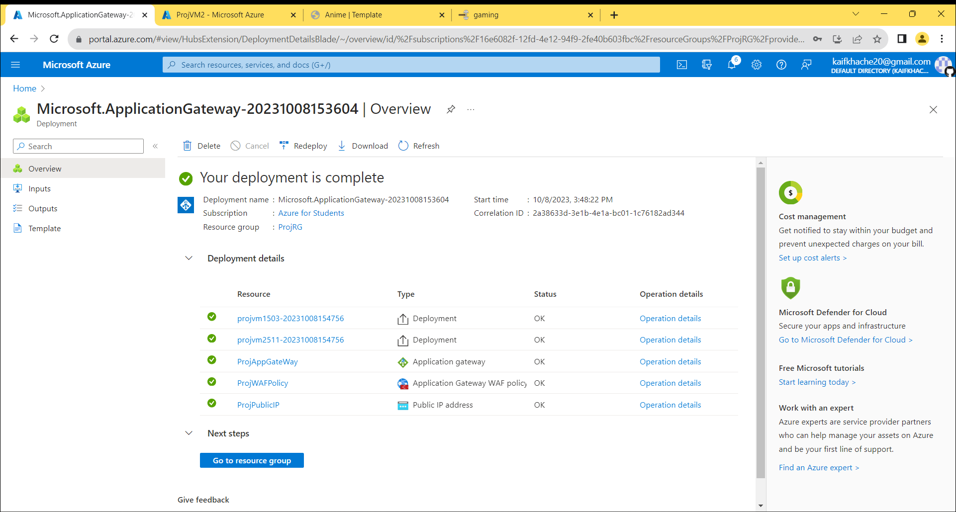

Connect to the Virtual Machines

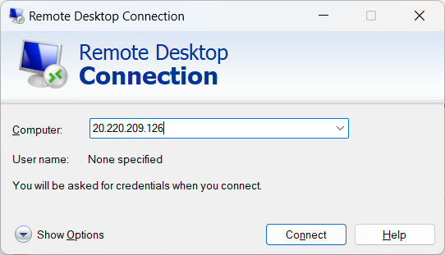

Install IIS server in both Virtual Machine

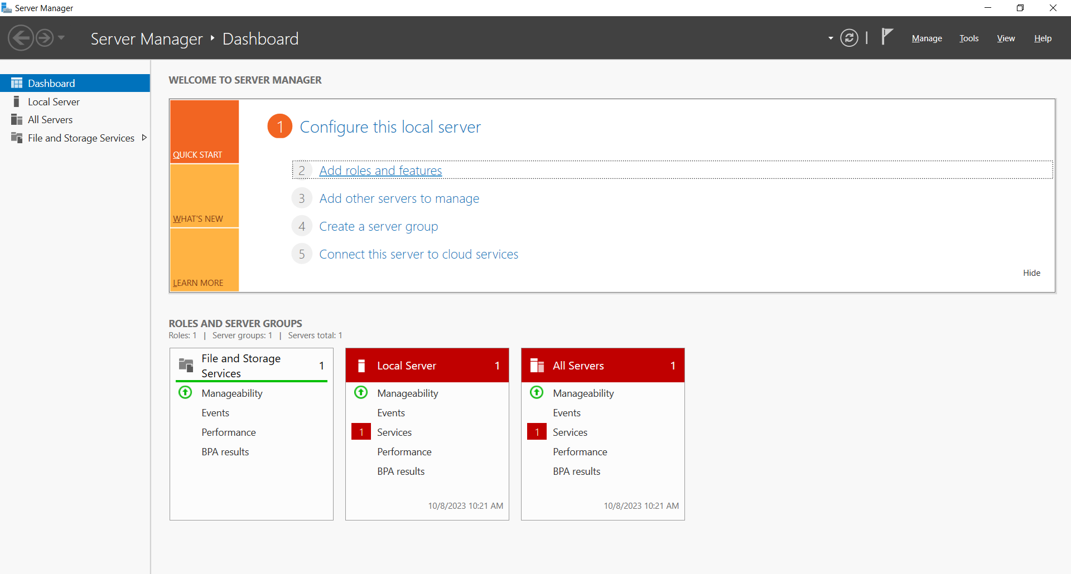

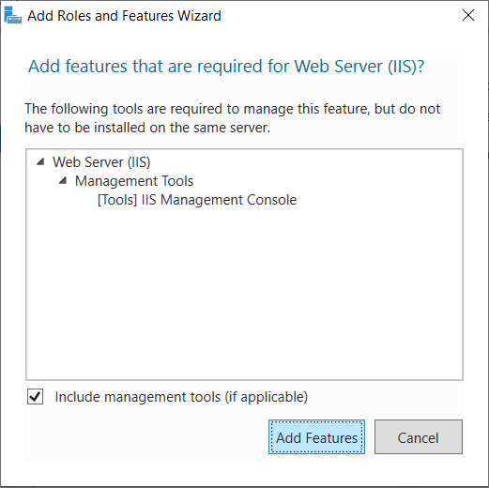

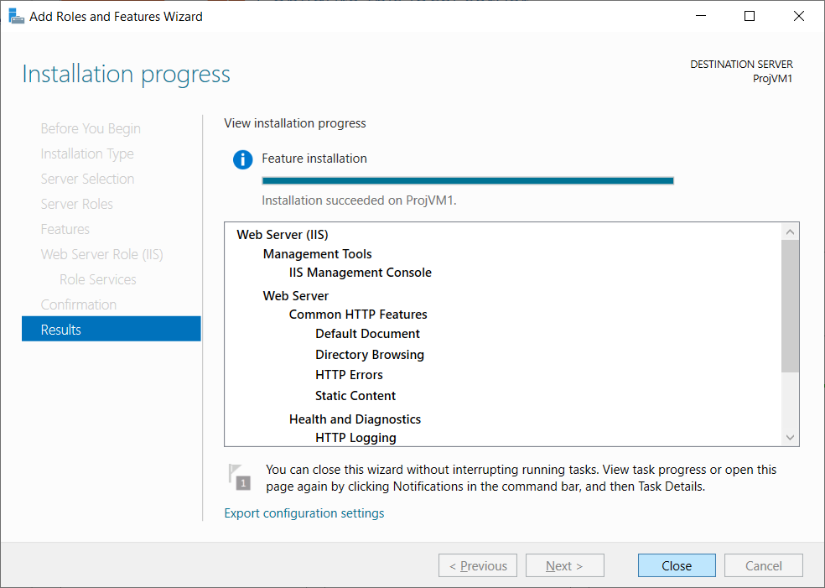

Keep the application file in Windows(c)/inetpub/wwwroot

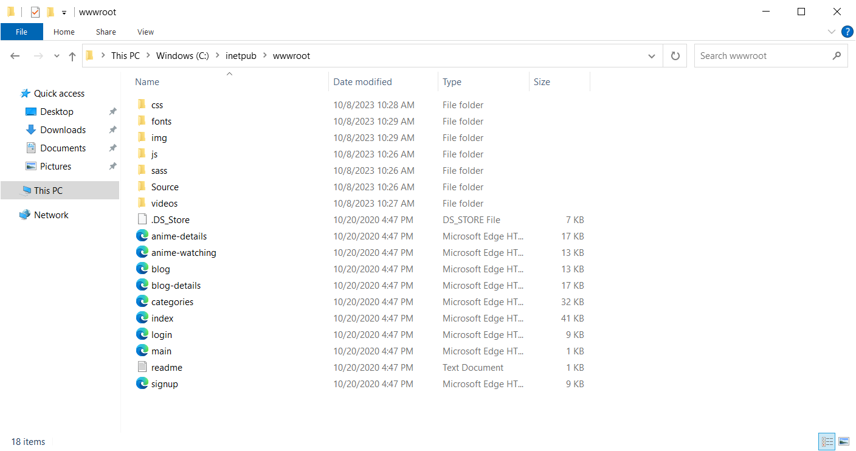

Enable and set the DNS name of Virtual Machine

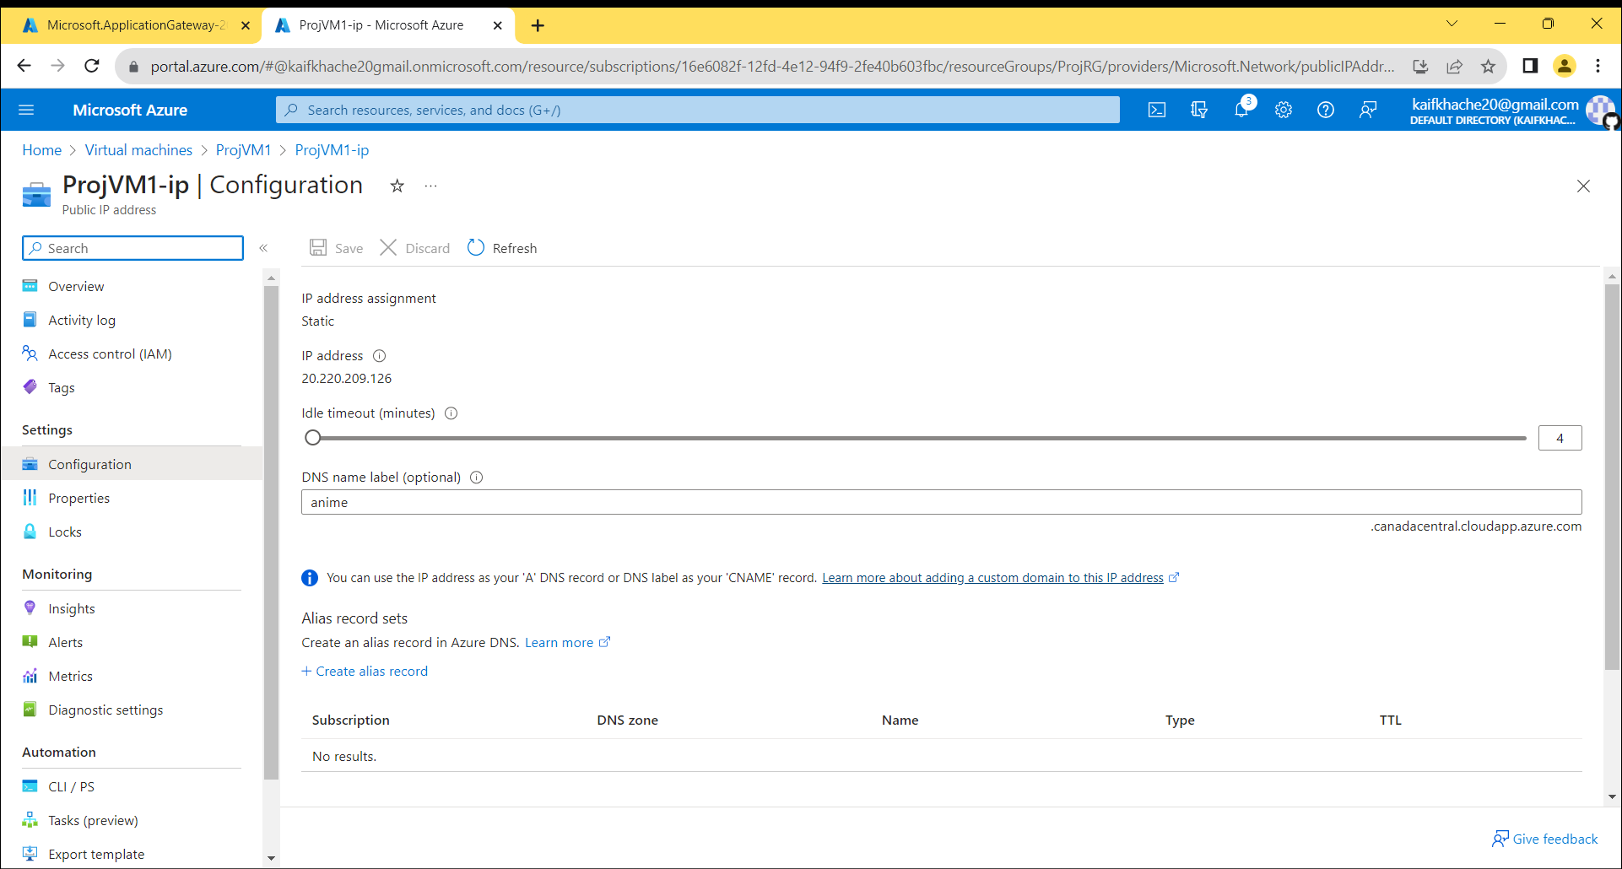

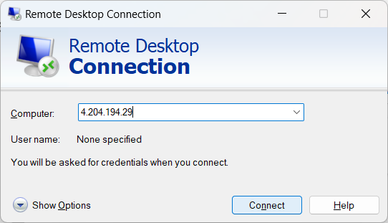



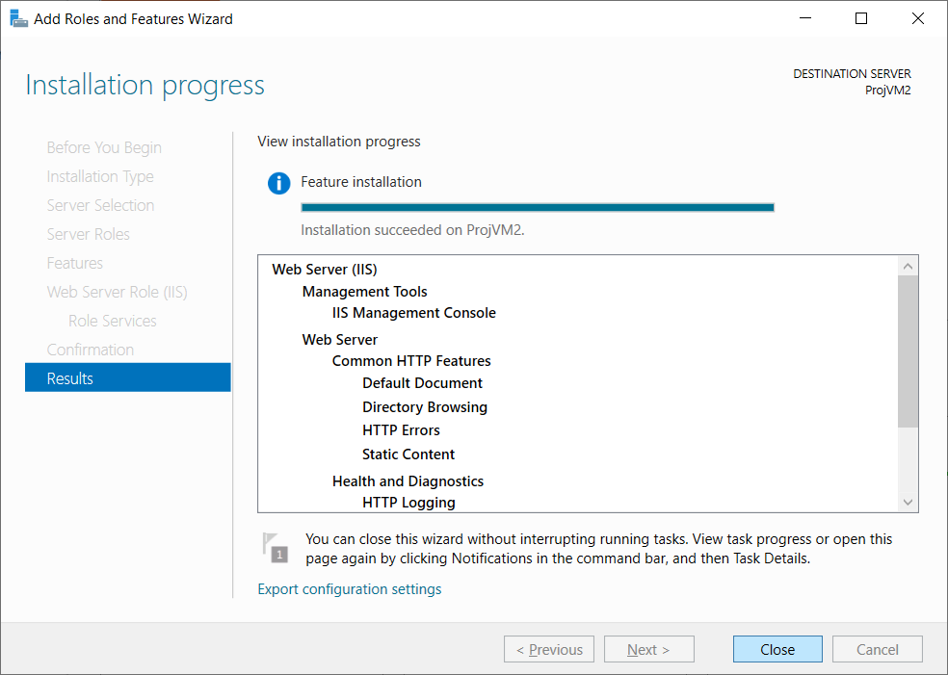

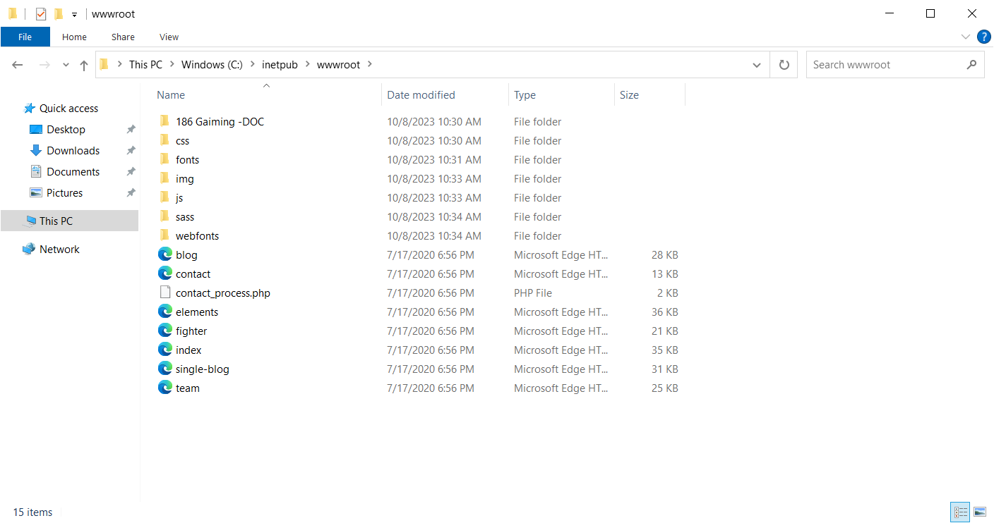

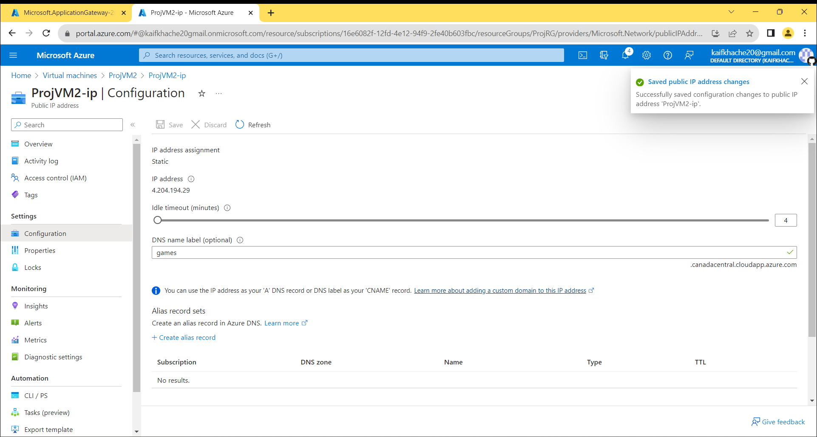

Copy the Application Gateway Public IP address and paste it in local host with Domain name

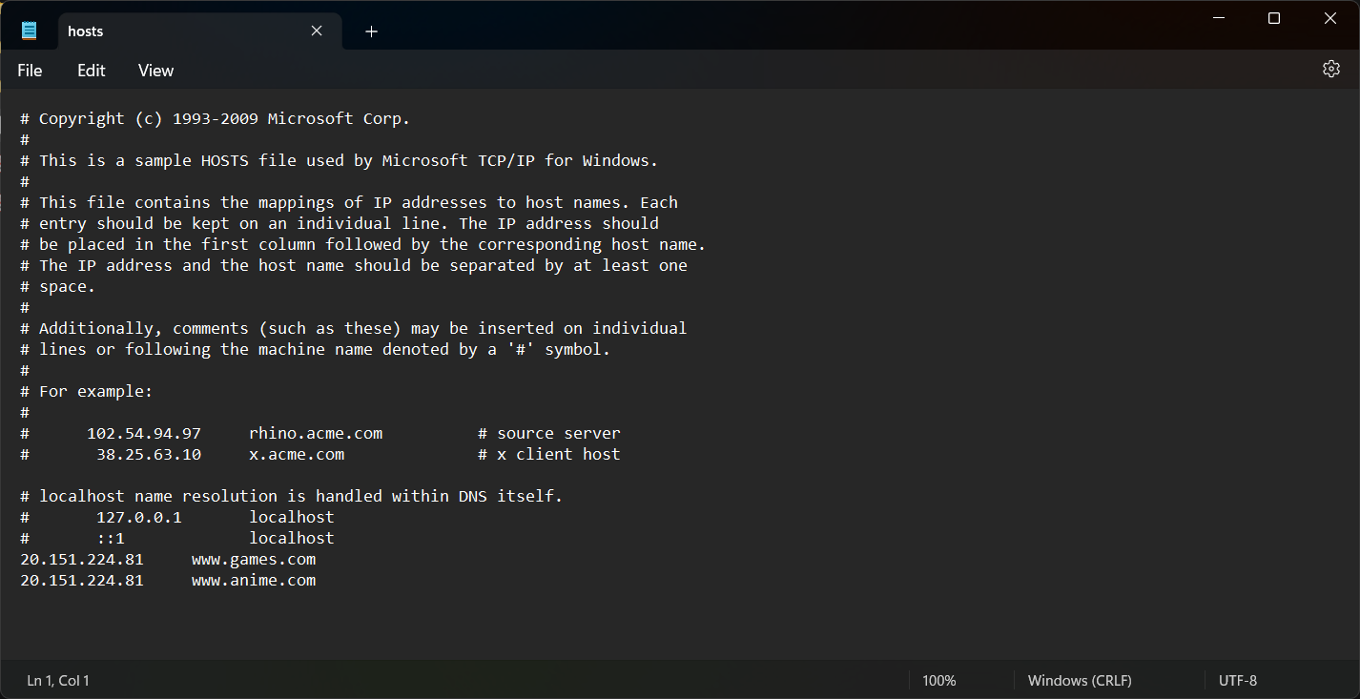

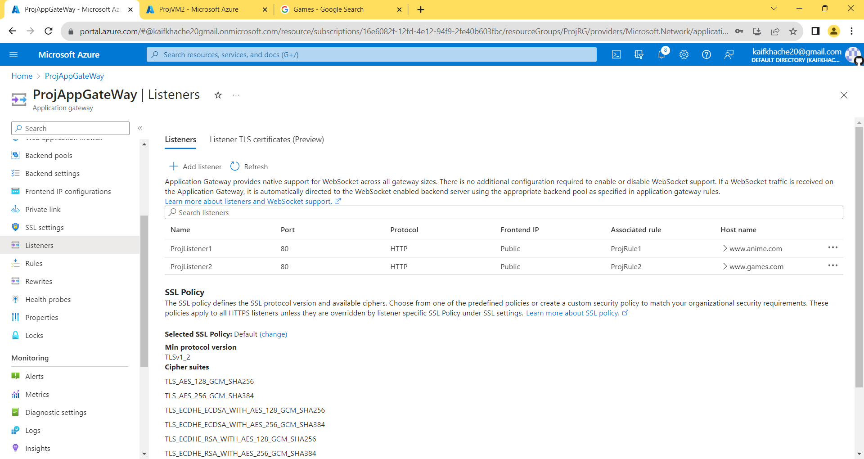

Hosting Web Application through Domain name in Host File

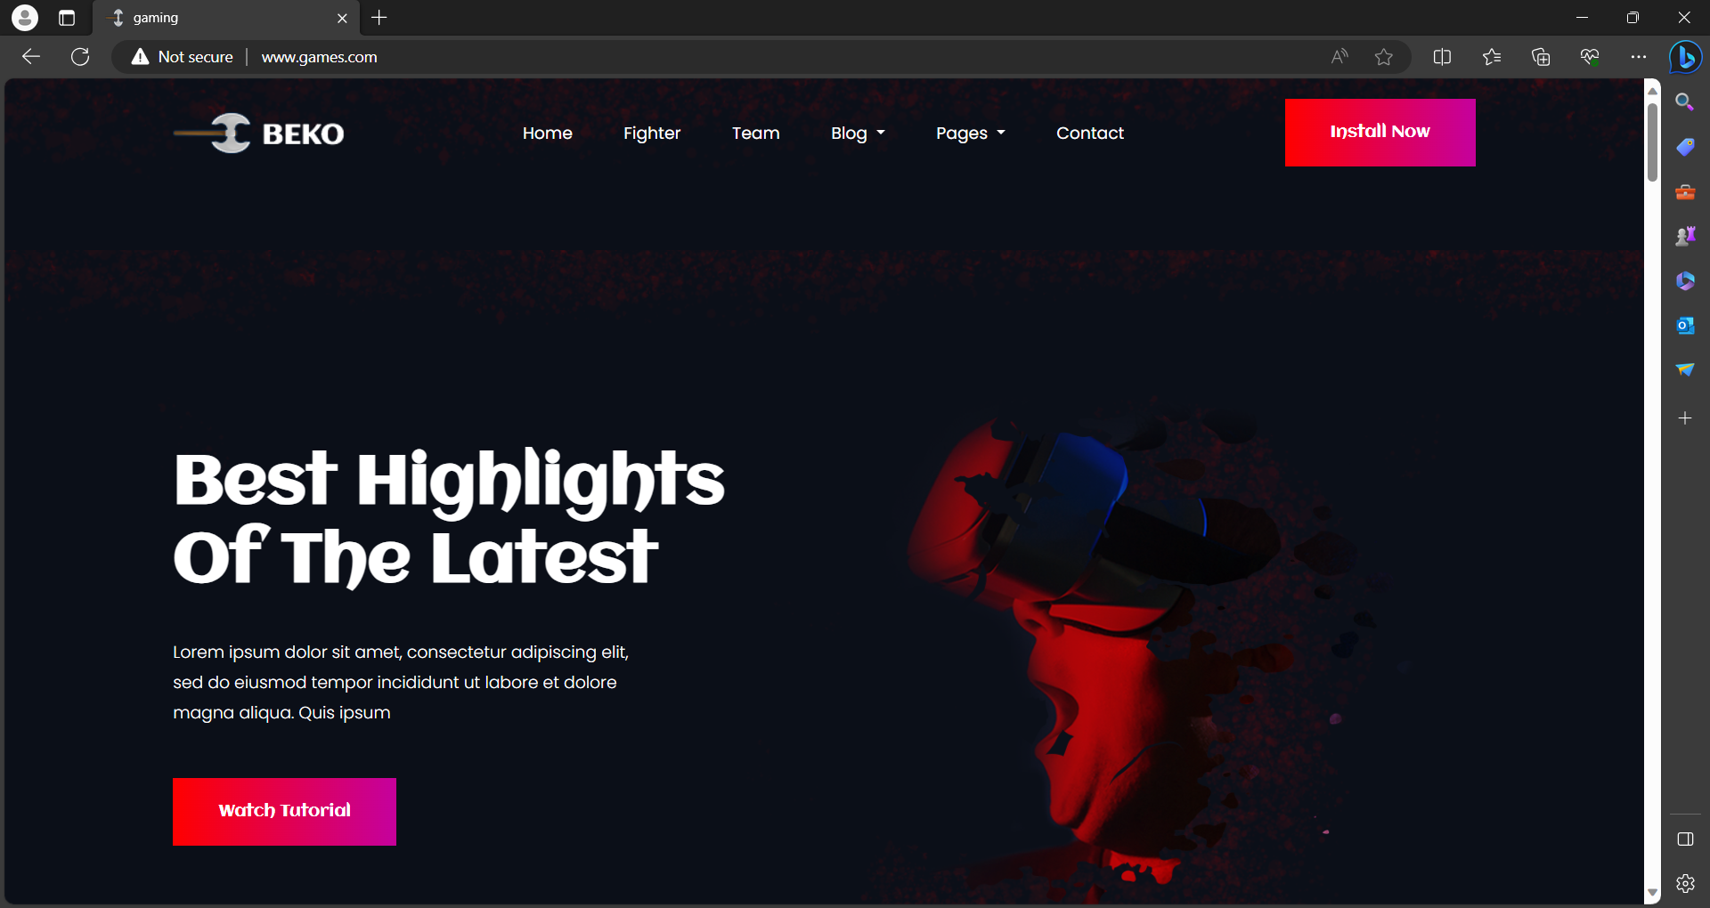

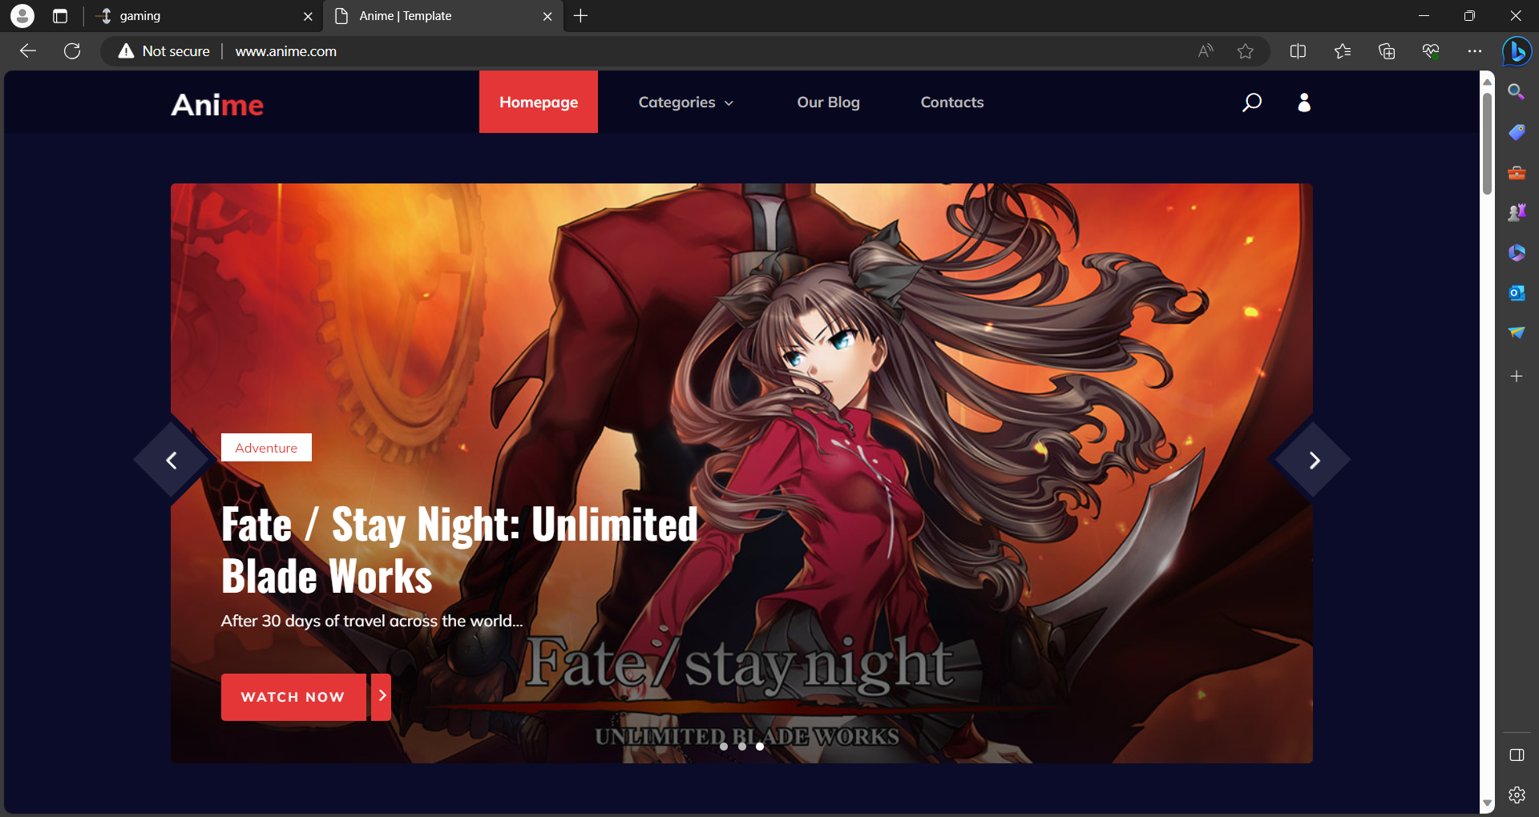

Create a Traffic Manager

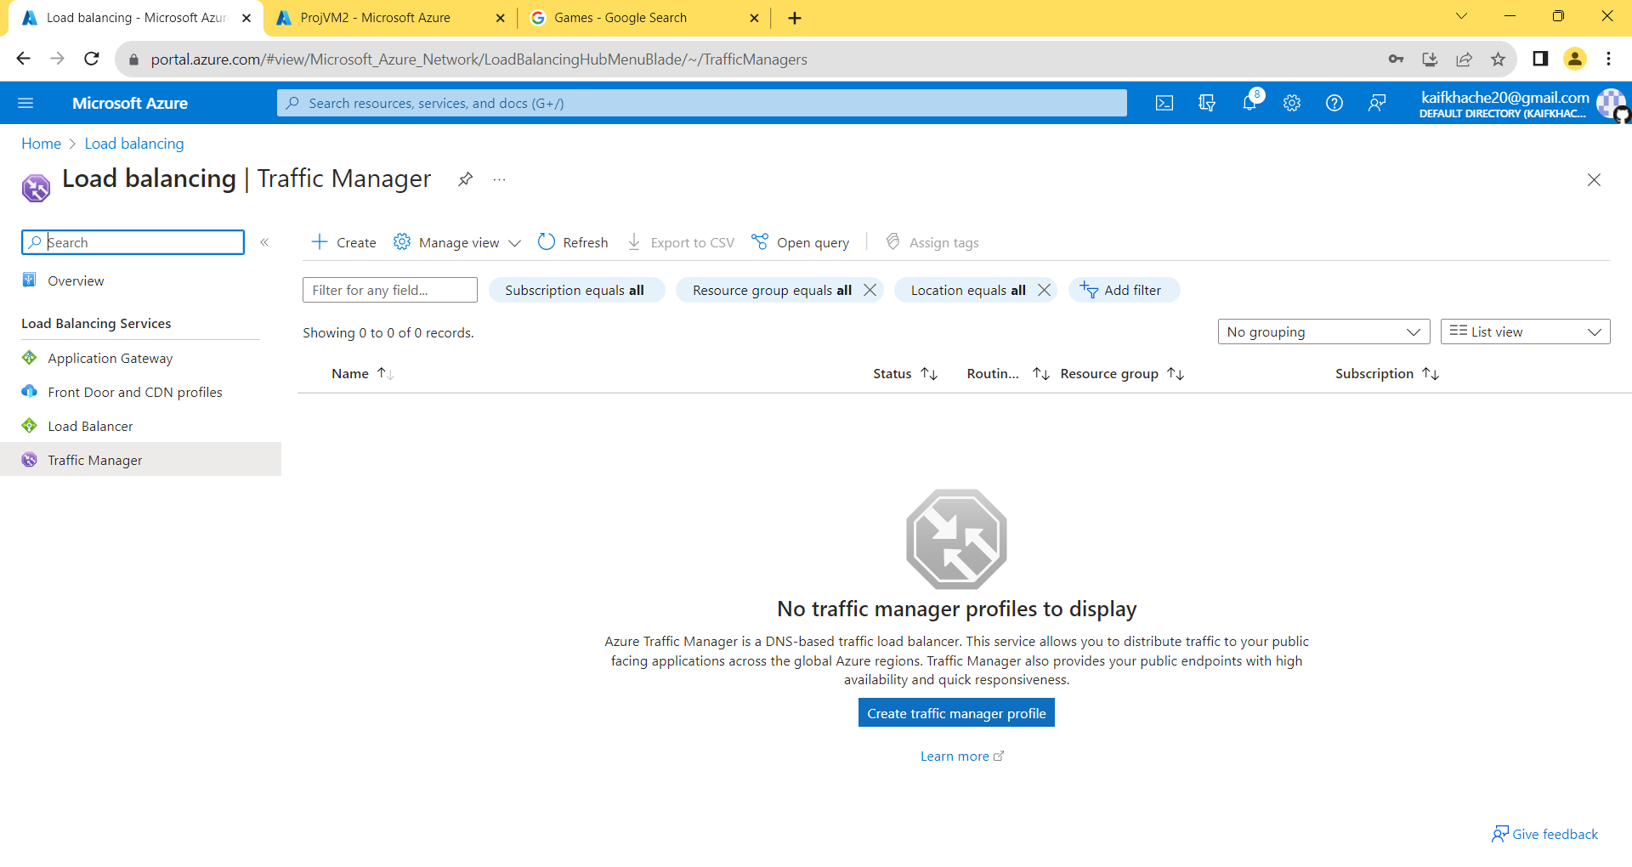

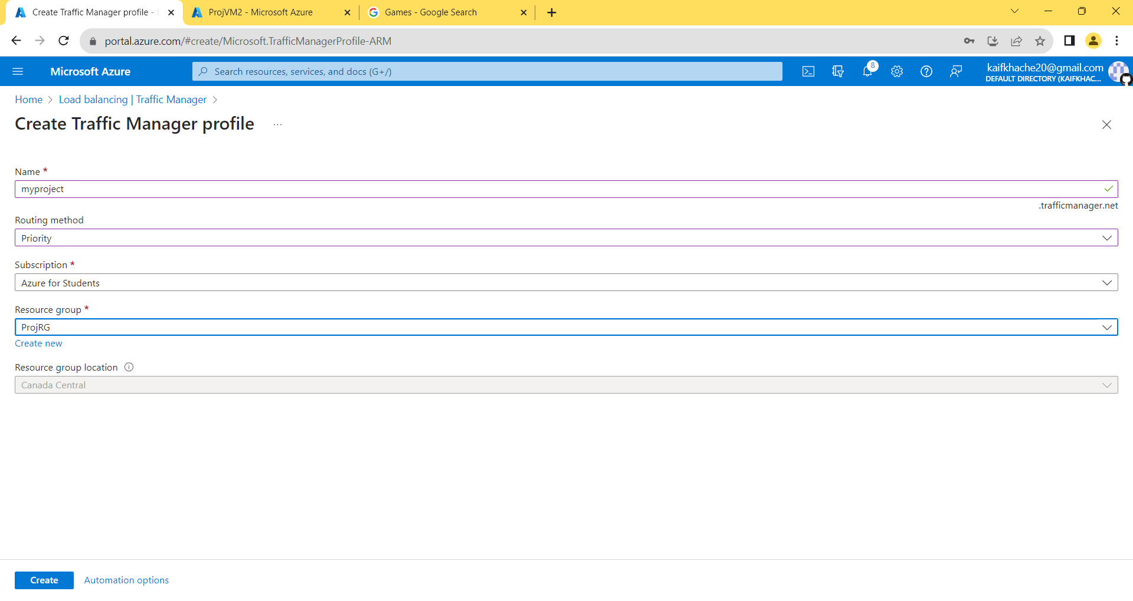

Set the End Point of Traffic Manager of both the Endpoint

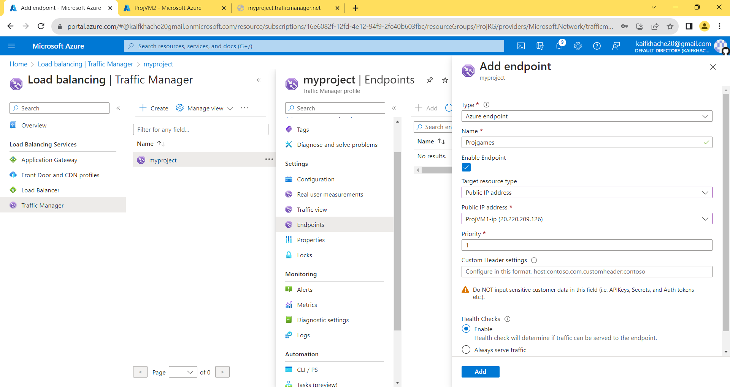

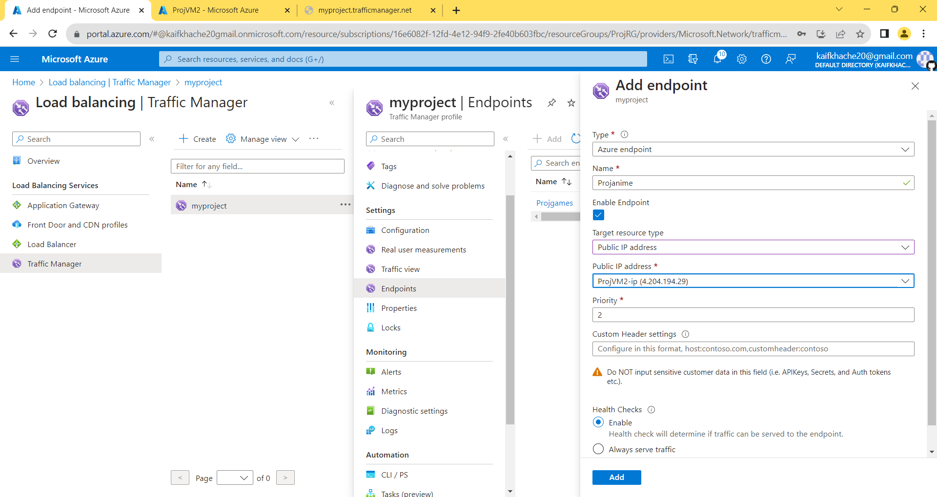

Hosting Website Through Traffic Manager by Routing Method Priority. 